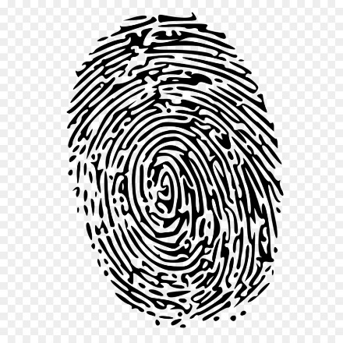
Forensic Science
Coach Jirasakhiran– Room 406

EMAIL: molly.jirasakhiran@cobbk12.org
PHONE: (770) 578-3200 ext.1406
BLOG: www.sprayberrysciencej.weebly.com
REMIND 101:
1st Period Text @c6g4ef to 81010
3rd Period Text @h38k774​ to 81010
4th Period Text @e3eg2h to 81010
Textbook: See attached page on how to join!

Course Description:
Forensics is a field of science dedicated to the methodical gathering and analysis of evidence to establish facts that can be presented in a legal proceeding. Forensic science is a very broad field of science which includes anthropology, chemistry, biology, genetics, entomology, mathematics, physics, odontology, reconstruction, technology, toxicology, and latent print identification.
Because Forensics encompasses many fields of science, students must have a thorough understanding of biology and chemistry in order to take this class. Television has helped to generate an interest in Forensic science. While the class will be lab oriented and intriguing, the course work, projects, and labs will be rigorous and include regular written assignments and mathematical applications. Students must be prepared to work hard!
GRADING:
A = 100% – 90, B = 89% - 80, C= 79% - 74 D= 73%-70, F= 69% - 0
Category | Percent
Homework | 5 %
Quiz/Classwork (smaller labs) | 15 %
Unit Tests | 35%
Projects (large labs) | 35 %
Cumulative Final Exam | 10 %
Total | 100%
Materials Needed
- 3 – ring binder
- A pack of 8 or more dividers
- Notebook paper
- Pen and pencil/ Highlighters

Policies:
- Take responsibility for yourself and your actions at all times.
- Missed assignments are to be picked up (or use the blog or email me) the day of your return and completed and turned in the following day. You get 1 day to complete your assignment for each day you miss.
- Late Work turned in late is worth 50% at best up until the day of the unit test. After that, the zero will remain a zero.
- Late projects (not due to excused absences) turned in late will be deducted 10 points from the final project grade each day until they are worth no points.
- Student agendas are to be kept with you at all times. They will serve as hall passes as well as a class calendar.
- It is the student’s responsibility to complete missed labs/tests in a timely manner. Students should use the blog for data and complete the lab asap. Make an appointment with me before/after school, or during A.O. to complete a missed test.
- Tardies/absences are to be dealt with according to the school policies.
- Test retakes must be redone before the next unit is finished and can be redone only once. All students are allowed to retake tests. The “retake contract” must be fulfilled first. The higher of the two grades will be accepted as the new grade.
- Cheating will result in zeros for all parties involved followed by a discipline referral.
- The New Cell Phone Policy will be implemented in EVERY classroom. If I ask you to put it away, please put it in your bag. We will use them sometimes in class.
Work will be collected often. Some of it may be graded, some may not. You should make every effort to complete it as accurately as possible.
Units:
SGM
CSI Investigation, Trace Evidence, Hair
- Little Red Riding Hood Book, Case Study, Swiffer Lab, Microscope Lab, Suspect Comparison Hair Lab Write-Up, Hair Diameter Lab, Microscope Quiz, Vocab Quiz, Unit Test
Fibers and Arson
- Suspect Fiber Comparison Lab Lab Write-up, Fiber Burning Lab, House Engineering Lab, Dollhouse Burning, Vocab Quiz, Unit Test
Fingerprints and DNA Fingerprinting
- Sticky Fingers Lab, Ninhydrin+Cyanoacrylate+Iodine Lab Write-Up, Online Gel Electrophoresis Lab, Vocab Quiz, Unit Test
Death and Anthropology
- Body Farm Lab Write-Up, Rigor+Algor+Livor Mortis Practice, Death Quiz, Body Posters, Anthropology Lab Practical, Skeleton/Vocab Quiz, Unit Test
Drugs and Handwriting
- Handwriting Testimony Lab, Drug Lab Write-Up, Vocab Quiz, Unit Test
Blood Spatter and Blood Type
- Blood Type Lab Write-Up, Blood Type/Vocab Quiz, Passive Drop Height Lab, Angle of Impact Lab, Cumulative Lab and Directions, Blood Math/Vocab Quiz, Unit Test
Casts and Impressions
- Tire Impressions and Wheelbase Lab, Shoe Print Lab, Golf Cart Demo, Dental Lab, Unit Test
Glass and Ballistics
- Glass Lab Write-Up
Cumulative Final Court Project and SGM
If you would like to donate classroom materials, here is a good list!
Clear packaging tape Clear Scotch Tape Black Ink Pads Cardboard Boxes
Karo Syrup String Plaster of Paris Red Food Coloring
Aluminum Foil Sandwich Bags toothbrushes White Balloons
Colored Paper Tissues Soap Sponges
Pencils/colored pencils Sharpies Markers/pens Crayons

