APES REVIEW GUIDE

AP exam
Table of Contents

Part 1: Managing your Time
Six Week (ish) Study Plan | pg. 2

Part 2: Keys to passing the APES exam
Multiple Choice | pg. 3
Free Response Tips | pg. 4
The Math | pg. 5
Experimental Design | pg. 5
Graphing | pg. 5
Major APES Themes | pg. 6
Exam Topic Outlines and weights | pg. 6

Part 3: Review Questions and Vocab Lists
Living World | pg. 11
Populations | pg. 24
Earth Systems | pg. 11
Land and Water Use | pg. 28
Energy Use and Consumption | pg. 34
Pollution | pg. 39
Global Change | pg. 46

Part 4: Case Study Connections
Case Studies | pg. 49

Part 5: Reference Sheets
Must know math | pg. 61
Metric system | pg. 62

The six-week study plan
Use this calendar to help you systematically prep for the AP exam. If you are a quick learner, use the lower suggested time. If you take more time studying, use the higher suggested time. You can also study other items such as the review books and apps. I suggest you cross off or highlight items on the chart as you do them. It’ll motivate you to see your progress!
Study tips: Eliminate distractions. Put your phone in another room. Don’t watch TV or have social media/games open on the computer while you use it. Listen to classical or soothing music or none at all. Find a quiet area. Eat a healthy snack for brain power
 | Week 1  March 25 | Week 2  April 1 | Week 3  April 8 | Week 4  April 15 | Week 5  April 22 | Week 6  April 29
Time per day | 15-30 min | 15-30 min | 15-30 min | 30-60 min | 30-60 min | 60-90 min
Topics to review | Ecology | Earth systems, Soil and Agriculture | Human Populations, Toxicology & Waste | Energy and Mining | Air and Water pollution | Everything
Practice FRQs  Found Publicly. Type “APES FRQ (YEAR) (NUMBER)” Answer keys have also been released. | 2000 #3  2010 #2  2014 #4 | 2009 #4  2005 #2  2004 #4 | 2008 #4  2003 #2  2000 #4  2008 #2 | 2012 #1  2011 #1  2009 #2  2008 #3 | 2013 #1  2011 #2  2007 #3  2006 #2
Spend extra time on these concepts | Nitrogen cycle, succession, primary productivity, invasive species | El Nino, soil texture, salinization, desertification | Population graphs and math, Bio-accumulation, IPM | Energy pros and cons; math; env. Impacts of mining | Eutrophication, water quality testing, climate change, pollutant source and effect
Bozeman science videos**  http://www.bozemanscience.com/ap-environmental-science | 001, 007, 008, 009, 010, 011, 012, 035 | 002, 003, 006, 016, 017, 018 | 013, 014, 015, 021, 031, 032 | 019, 022, 023, 024, 025, 026, 027, 028 | 004, 005, 020, 029, 030, 033, 034
*As you look back at the material, highlight or make note of the topics you have trouble remembering. You can ask for help during class and focus your studying in the end on the harder topics.
** Bozeman website: http://www.bozemanscience.com/ap-environmental-science

Keys to Passing the APES Exam (Obviously this will not be the case this year. 45 Minutes of FRQ).
Below are some general test-taking skills that should help you in this section.

Free Response Questions Hints
Overview of the types of questions
There are three types of questions. An Analysis of a Data Set question where you interpret graphs, maps or charts. One Environmental Problem question, you will have to read a document and answer questions/perform calculations based on that information as well as your general knowledge. There is one Experimental Design question. This question will involve formation of a hypothesis/null hypothesis, identification of variables and constants, and explanation of appropriate data collection.

Each question is graded on a 10-point scale. Some of the grading rubrics are set up to contain slightly more than 10 points (e.g., 11-13). However, you can only earn a maximum of 10 points on any one question. Use a ballpoint pen with dark black ink.

Task Verbs
Pay close attention to the task verbs used in the free-response questions. Each one directs you to complete a specific type of response. Here are the task verbs you’ll see on the exam:
- Calculate: Perform mathematical steps to arrive at a final answer, including algebraic expressions, properly substituted numbers, and correct labeling of units. Showing work is required.
- Describe: Provide the relevant characteristics of a specified topic.
- Explain: Provide information about how or why a relationship, process, pattern, position, situation, or outcome occurs, using evidence and/or reasoning to support or qualify a claim. Explain “how” typically requires analyzing the relationship, process, pattern, position, situation, or outcome; whereas, explain “why” typically requires analysis of motivations or reasons for the relationship, process, pattern, position, situation, or outcome. Also phrased as “give one reason.”
- Identify: Indicate or provide information about a specified topic, without elaboration or explanation.
- Justify: Provide evidence to support, qualify, or defend a claim and/or provide reasoning to explain how that evidence supports or qualifies the claim.
- Make a claim: Make an assertion that is based on evidence or knowledge.
- Propose a solution: Provide a proposed solution to a problem based on evidence or knowledge.

Succeeding on the FRQs
The national average for the essay section will be about 50% correct (i.e., 5/10). It is very likely that you will not know everything, this is expected, but it is very likely that you do know something about each essay, so relax and do the best you can. Don't panic or get angry because you are unfamiliar with the question. Often they’ll pick topics from the news that you may or may not be familiar with. You probably have read or heard something about the subject - be calm and think... look for classroom connections to the topics and use those clues to guide your answers.

- Don't leave questions blank. Each point you earn on an essay question is the equivalent of two correct multiple-choice questions, and there is no penalty for a wrong guess, bad spelling or bad grammar. Make an effort on every question! Don't Quit!
- You cannot list items in an outline form. Use normal sentence structure to give a list of items.
- Read all three questions first, before you attempt to answer them. Start with the question you find the easiest for you to answer, many times while answering one question, you will recall answers to other questions, write down this information so you don’t forget it.
- Before you begin to answer any question, carefully reread the question, circle key words. Be sure to answer the question(s) asked and only those questions; and answer all parts of the question. If you are given a choice of parts to answer, choose carefully. It is best if you can answer the question parts in the order called for, but you don’t have to.
- It is a great idea to label the parts "a", "b", "c", etc. as they are labeled in the question. You can always answer the earlier parts later and you don’t need to save space, just label the section. If you can’t answer all of the parts of the question, answer what you can, you get credit for what you write if it fits the rubric, some points are better than none.
- Outline the answer to avoid confusion and disorganization. Pay close attention to words used in the directions, such as describe, explain, compare, contrast, identify, support, provide evidence for, graph, calculate, etc., and be sure to follow those directions.
- If it asks for two examples, then only the first two are graded, if you give three and the first one is incorrect, then you won’t get that point. Extra points are usually available for elaboration, when they are given.
- Outlines and diagrams, no matter how elaborate and accurate, are not essays, and will not get you much credit, if any, by themselves, write the essay.
- If asked to draw a diagram, be sure to label the components carefully and correctly.
- Define and/or explain any terms you use. Say something about each of the important terms that you use. Rarely would the exam ask for a list of buzzwords.
- Write clearly and neatly. If the grader can’t read the answer because of penmanship, then you will more than likely receive a Zero (0) for the question.
- Go into detail that is on the subject and to the point. Be sure to include the obvious (for example, "light is necessary for photosynthesis"). Answer the question thoroughly.
- If you cannot remember a word exactly, take a shot at it, get as close as you can. Even if you don't remember the name of the concept, describe the concept.
- Remember that no detail is too small to be included as long as it is to the point. Be sure to include the obvious, most points are given for the basics anyway.
- Be concise. Be precise. This is a science test not an English test. Give examples whenever you can, but still be concise.

Tips for the mathematical FRQ
Do this FRQ last! Save all the mathematical calculations for last since they take time.
- Most math based FRQs have written questions following them. You can earn significant amounts of points on these sections. Often students get stuck on a math problem and run out of time to answer the easier points. Answer the written portions first if you can and then go back and calculate last.
- On the math- write out the formulas and show your work! Many times, points are awarded for setting up the problem. If you provide only the answer and did not show how you obtained the answer, you will receive no points.
- Show all units! Be really specific about what your numbers represent.
- Show all your calculations in the answer spaces. You can use your question booklet to think through the problem but then show an organized solution in the answer booklet showing all your work.

When they ask for experimental design…
There have been several years where there has been an experimental design question. You have a lot of practice with this in the lab! Think through how we do experiments and write a full lab report. Do all of those same actions on the FRQ. If you are asked to design or describe an experiment, be sure to include the following:
- hypothesis and/or predictions
- identify the independent variable - what treatments will you apply
- identify the dependent variable - what will you measure
- identify several variables to be controlled (very important)
- describe the materials you would use to conduct the experiment. Be specific!
- describe what you will actually do. Give a specific list of steps you’d follow.
- describe how you will actually take and record data
- describe how the data will be graphed and analyzed
- state how you will draw a conclusion (claim-evidence-reasoning with comparison of outside sources)
Your experimental design needs to be at least theoretically possible and it is very important that your conclusions/predictions be consistent with the principles involved and with the way you set up the experiment. When designing the experiment, I suggest you plan it backwards. Work from the expected result to the hypothesis. This is a great place to use the question booklet for planning.

When they ask you to graph…
- set up the graph with the independent variable along the x-axis and the dependent variable along the y-axis
- mark off axes in equal (proportional) increments and label with proper units
- plot points and attempt to sketch in the curve (line)
- if more than one curve is plotted, write a label on each curve
- label each axis
- give your graph an appropriate title (what is it showing?)

Science Practices
The AP Environmental Science practices describe what a student should be able to do while exploring course concepts. The table that follows presents these practices

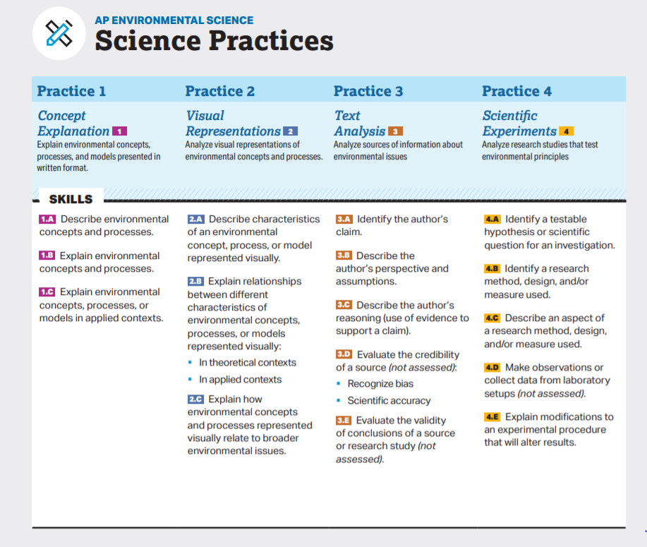

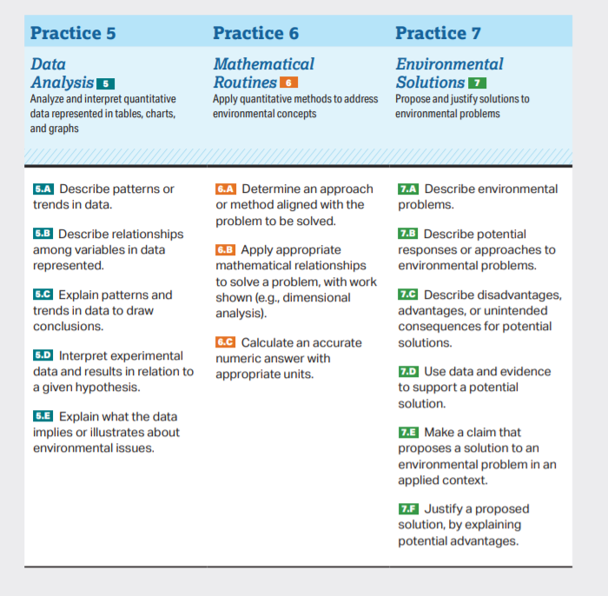

Topic Outline

Unit 1: The Living World - Ecosystems

  - Introduction to Ecosystems
  - Terrestrial Biomes
  - Aquatic Biomes
  - The Carbon Cycle
  - The Nitrogen Cycle
  - The Phosphorous Cycle
  - The Water Cycle
  - Primary Productivity
  - Trophic Levels
  - Energy Flow and the 10% Rule
  - Food Chains and Food Webs

Unit 2: The Living World - Biodiversity

  - Introduction to Biodiversity
  - Ecosystem Services
  - Island Biogeography
  - Ecological Tolerance
  - Natural Disruptions to Ecosystems
  - Adaptations
  - Ecological Succession
Unit III. Populations (10 – 15%)

  - Generalist and Specialist Species
  - K-Selected and R-Selected Species
  - Survivorship Curves
  - Carrying Capacity
  - Population Growth and Resource Availability
  - Age Structure Diagrams
  - Total Fertility Rate
  - Human Population Dynamics
  - Demographic Transitions

Unit IV. Earth Systems and Resources(10 – 15%)
  - Plate Tectonics
  - Soil Formation and Erosion
  - Soil Composition and Properties
  - Earth’s Atmosphere
  - Global Wind Patterns
  - Watersheds
  - Solar Radiation and Earth’s Seasons
  - Earth’s Geography and Climate
  - El Nino and La Nina

Unit V. Land and water Use (10 – 15%)

5.1 The Tragedy of the Commons
5.2 Clearcutting
5.3 The Green Revolution
5.4 Impacts of Agricultural Practices
5.5 Irrigation Methods
5.8 Pest Control Methods
5.7 Meat Production Methods
5.8 Impacts of Overfishing
5.9 Impacts of Mining
5.10 Impacts of Urbanization
5.11 Ecological Footprints
5.12 Introduction to Sustainability
5.13 Methods to reduce Urban Runoff
5.14 Integrated Pest Management
5.15 Sustainable Agriculture
5.16 Aquaculture
5.17 Sustainable Forestry

Unit VI. Energy Resources and Consumption (10 – 15%)

6.1 Renewable and Nonrenewable Resources
6.2 Global Energy Consumption
6.3 Fuel Types and Uses
6.4 Distribution of Natural Energy Resources
6.5 Fossil Fuels
6.6 Nuclear Power
6.7 Energy from Biomass
6.8 Solar Energy
6.9 Hydroelectric Power
6.10 Geothermal Energy
6.11 Hydrogen Fuel Cell
6.12 Wind Energy
6.13 Energy Conservation
Unit VII. Atmospheric Pollution (7-10%)
  - Introduction to Air Pollution
  - Photochemical Smog
  - Thermal Inversion
  - Atmospheric CO₂ and Particulates
  - Indoor Air Pollutants
  - Reduction of Air Pollution
  - Acid Rain
  - Noise Pollution

Unit VIII. Aquatic and Terrestrial Pollution (7-10%)
  - Sources of Pollution
  - Human Impacts of Ecosystems
  - Endocrine Disruptors
  - Human Impacts on Wetlands and Mangrovescvbn
  - Eutrophication
  - Thermal Pollution
  - Persistent Organic Pollutants (POPs)
  - Bioaccumulation and Biomagnification
  - Solid Waste Disposal
  - Waste Reduction Methods
  - Sewage Treatment
  - Lethal Dose 50% (LD₅₀)
  - Dose Response Curve
  - Pollution and Human Health
  - Pathogens and Infectious Diseases

Unit IX. Global Change (15 – 20%)

9.1 Stratospheric Ozone Depletion
9.2 Reducing Ozone Depletion
9.3 The Greenhouse Effect
9.4 Increases in Greenhouse Gases
9.5 Global Climate Change
9.6 Ocean Warming
9.7 Ocean Acidification
9.8 Invasive Species
9.9 Endangered Species
9.10 Human Impact on Biodiversity

Unit 1: The Living World (6-8%)

Vocabulary:

- abiotic
- aerobic respiration
- ammonia
- ammonification
- aquifer
- assimilation
- autotroph
- bacteria
- benthos
- biogeochemical cycle
- biome
- biosphere
- biotic
- deciduous plants
- carbon cycle
- carbon sink
- carrying capacity
- climax community
- coastal wetland
- commensalism
- community
- coniferous trees
- coral reef
- deciduous plants
- decomposer
- denitrification
- detritivore
- detritus
- detritus feeder
- diffusion
- ecology
- ecosystem
- energy productivity
- estuary
- eutrophication
- fermentation
- first law of thermodynamics
- food chain
- food web
- freshwater life zones
- fundamental niche
- gross primary productivity (GPP)
- groundwater
- habitat
- herbivore
- heterotroph
- host
- hydrologic cycle
- infiltration
- kilocalorie (kcal)
- law of conservation of energy
- law of conservation of matter
- leaching
- limiting factor
- mutualism
- net primary productivity (NPP)
- niche
- nitrate
- nitrogen cycle
- nitrous oxide
- nitrogen fixation
- nitrogen oxides
- nitrification
- omnivore
- parasitism
- phosphate
- phosphorus cycle
- photosynthesis
- phytoplankton
- plankton
- precipitation
- predation
- primary consumer
- primary productivity
- producer
- pyramid of energy flow
- riparian zones
- runoff
- scavenger
- second law of energy
- second law of thermodynamics
- secondary consumer
- species
- sulfur cycle
- sulfur dioxide (SO2)
- sulfuric acid (H2SO4)
- surface runoff
- surface water
- Symbiotic Relationships
- terrestrial
- tertiary (higher-level) consumers
- transpiration
- trophic level
- water cycle
- water table
- zone of aeration
- zone of saturation

Review Questions:

  - What are five biotic and five abiotic factors we might study in an ecosystem? How might these impact the carrying capacity of an ecosystem?

  - List and describe (or draw a picture and add captions) of the water cycle. Which steps are humans most likely to interfere (intentionally or otherwise)?

  - List and describe (or draw a picture and add captions) of the carbon cycle. Which steps are humans most likely to interfere (intentionally or otherwise)? What would be the likely consequence(s) of such interferences?

  - List and describe (or draw a picture and add captions) of the nitrogen cycle. Which steps are humans most likely to interfere (intentionally or otherwise)? What would be the likely consequence(s) of such interferences?

  - List and describe (or draw a picture and add captions) of the phosphorus cycle. Which steps are humans most likely to interfere (intentionally or otherwise)? What would be the likely consequence(s) of such interferences? How is the phosphorus cycle different from the other biogeochemical cycles?

  - Complete the following table for these biogeochemical cycles:
Trait | Carbon | Nitrogen | Phosphorus | Water
Importance to life
Largest reservoir
Methods of transport
Cycle duration (long/short)

  - Name the molecules that match each step of the nitrogen cycle: (FIXNAAD ANPAN)
Nitrogen fixation
Nitrification
Assimilation
Ammonification
Denitrification

  - For each of the following species interactions, define it and give a common example.
Symbiotic Relationship | Definition | Two Examples of Each  Indicate with a +/- which benefits and which is harmed, if applicable
Mutualism

Commensalism

Parasitism

Competition

Predation

  - What climatic patterns determine the type of biome an area will have?

  - For each of the following biomes, identify a specific country in which each biome occurs in relative abundance:
Taiga ___________________ Desert
Tropical rainforest ___________________ Temperate grassland
Tropical grassland ___________________ Coral reef
Temperate deciduous forest Tundra

  - Fill out the chart below on the various biomes.
Type of Biome | Typical Location | Typical Climate | Characteristic adaptations for survival
Tropical Rain Forest |  |  | Plants –  Animals –
Temperate Deciduous Forest |  |  | Plants –  Animals –
Taiga (Boreal) Forest |  |  | Plants –  Animals –
Tropical Grasslands (Savanna) |  |  | Plants –  Animals –
Temperate Grassland (Prairie) |  |  | Plants –  Animals –
Tundra  (Cold Grassland) |  |  | Plants –  Animals –
Desert |  |  | Plants –  Animals –

  - List two environmental benefits of wetlands.

  - Label the four major zones of life in the appropriate areas on the diagram representing a temperate lake in the box to the right.

B. Energy Flow
  - Write the balanced chemical equation for photosynthesis in the box on the right. Label the reactants and products.
Photosynthesis:

Cellular Respiration:
  - Write the balanced chemical equation for cellular respiration in the box on the right. Label the reactants and products.

  - Perform the following calculation. Show all of your work. If the grasses on a 100-hectare area of grassland grow at an average rate of 1 cm/day, the average volume of grass that is added to the grassland each day is ____________ m³. If the density of the grasses that grow in the grassland averages 400 kg/m³, the net primary productivity is approximately _____________ g/m²/day or _____________ g/m²/year.

  - The net annual primary productivity of a particular wetland ecosystem is found to be 8,000 kcal/m2 . If respiration by the aquatic producers is 12,000 kcal/m2 per year, what is the gross annual primary productivity for this ecosystem, in kcal/m2 per year?

  - On the following food web, classify each species into its trophic level.
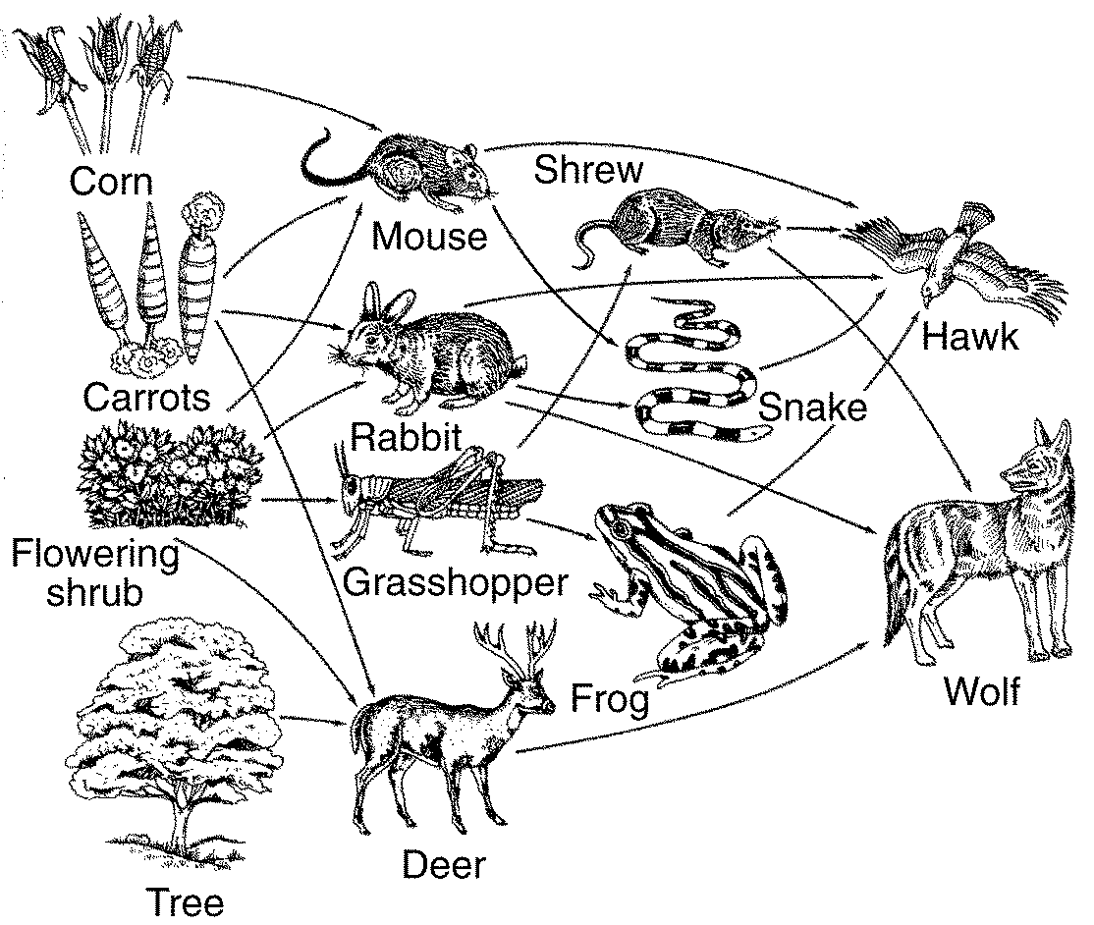
  - Next to the food web, draw an ecological pyramid using the food web above and determine the biomass of the deer if the wolf consumes 8943 kg. Label each trophic level in the pyramid.

  - Explain how the law of conservation of matter relates to the cycling of carbon through a food web.

  - How does Easter Island depict the flow of matter through an ecosystem?

  - Before a group of volunteers planted 400 mangrove trees, the gross annual primary productivity of a particular wetland ecosystem is found to be 22,000 kcal/m² . The trees have increased the gross primary productivity by 20%. What is the new GPP of the wetland?

Unit 2: The Living World: Biodiversity (6-8%)

Vocabulary:

- adaptation
- allele
- artificial selection
- background extinction
- biodiversity
- biological diversity
- bottleneck effect
- climax community
- competitive exclusion
- cultural services
- ecological diversity
- ecological niche
- ecosystem services
- endangered species
- edge effect
- endemic species
- evolution
- extinction
- fitness
- founder effect
- fundamental niche
- fundamental niche
- gene flow
- gene pool
- generalist species
- genetic diversity
- genetic drift
- geographic isolation
- habitat
- inbreeding depression
- indicator species
- interspecific competition
- intraspecific competition
- island biogeography
- keystone species
- limiting factor
- mass extinction
- mutation
- natural selection
- niche
- pioneer species
- population
- provisional service
- primary succession
- range
- range of tolerance
- realized niche
- regulating service
- reproductive isolation
- resource partitioning
- secondary succession
- Shannon Index
- specialist species
- speciation
- species
- species evenness
- species diversity
- species richness
- supporting services
- theory of evolution

Review Questions:

  - Match the following:
  - generalist species Zebra mussel
  - specialist species Galapagos tortoise
  - invasive species American Alligator
  - keystone species Tiger salamander
  - indicator species Norway rat
f. endemic Species Giant Panda

  - Contrast genetic, ecosystem and species biodiversity.

  - If a forest is fragmented due to deforestation, explain how the edge effects impact species diversity and population sizes.

  - What are two ways to reduce habitat fragmentation?

Ecosystem Diversity
  - Explain how preserving biodiversity is directly related to the availability of natural capital.

  - Explain how biodiversity increases the survival of a species during the process of natural selection and evolution.

  - What is the bottleneck effect? What is the founder effect? Provide an example of each and explain what happens to the representation of alleles in the gene pool.

  - Answer the question below and explain why each answer choice is correct or incorrect.

A farmer observes that increasingly higher concentrations of a particular pesticide have been required each year over the past ten years to achieve the same level of effectiveness on a specific insect pest. Which of the following best helps explain the observation?
        - Some individual insects live longer than others and pass on traits acquired during their lives.
        - Only the most aggressive and territorial insects survive and reproduce.
        - Some individual insects are more likely than others to survive and reproduce due to their inherited traits.
        - Some individual insects produce many offspring, and thus their offspring live longer.
        - Some individual insects reproduce before the pesticide is applied, thereby avoiding its harmful effects.

  - Compare/Contrast natural selection and artificial selection.

  - Two islands, different distances from the mainland have different rates of extinction, this is explained by the theory of island ________________________.

  - Complete the following table:
Ecosystem Service | Description of ecosystem service and two examples
Regulating
Supporting
Cultural
Provisioning

  - What are three examples of keystone species? Why are they so important?

  - Why are amphibians often considered an indicator species?

  - Contrast primary and secondary ecological succession. What types of events cause each? Contrast the pioneer species found in each.

Unit 3: Population 10-15%

Vocabulary

- age structure
- baby bust
- baby boom
- biotic potential
- birth rate
- carrying capacity (K)
- competitors
- crude birth rate
- crude death rate
- death rate
- demographic transition
- demography
- density dependent factors
- density independent factors
- developed country
- developing country
- doubling time
- growth rate
- ecological footprint
- economy
- emigration
- environmental degradation
- environmental ethics
- environmental resistance
- environmentally sustainable economic development
- exponential growth
- family planning
- famine
- fertility
- globalization
- gross domestic product (GDP)
- immigration
- industrialization
- infant mortality rate
- K-Selected Species
- J-curve
- less developed country (LDC)
- life expectancy
- limiting factor
- linear growth
- logistic growth
- malnutrition
- more developed country (MDC)
- natural capital
- opportunist
- overnutrition
- overshoot
- per capita
- population density
- population dispersion
- population distribution
- population dynamics
- population momentum
- population size
- post industrial
- post- reproductive age
- poverty
- pre-industrial
- pre-reproductive age
- post-industrial
- replacement-level fertility
- R-Selected Species
- rule of 70
- S- curve
- surplus
- survivorship curve
- total fertility rate (TFR)
- transitional

A. Population Biology Concepts

Population
Time
- Use the axes to the right for the following:
  - Draw and label a line that represents linear growth.
  - Draw and label a line that represents exponential growth.
  - Label carrying capacity (k)

- List the four most populated countries in the world.
- __________________________ (3)
- __________________________ (4)

- On the axes below, draw a line showing a population that exemplifies logistic growth. (s-curve) and label the carrying capacity.

Population
Time

- In 1987, the population of Black Footed Ferrets in the world was 18 individuals. By 1989 through captive breeding, the number rose to 120. What percent change is this? (round to nearest whole %)

- There are 300 births in a population of 1800 mountain lions. What is the birth rate?

- Describe the three survivorship types
Type 1:

Type 2:

Type 3:
- Fill in the chart below comparing R and K Selected Species

Characteristic | R-Selected Species | K-Selected Species
Typical Organism Size
Time to Reach Reproductive Maturity
Number of Offspring Per Reproductive Event
Gestational Time
Reproductive Events in a Lifetime
Life Expectancy

- Graph the three survivorship types below. Label R- and K- selected species. Label the environmental resistance and biotic potential.

B. Human Populations
- In what regions of the world is population density the greatest concern? How is population distribution a food and water security issue?

- Explain two reasons why a population can continue to grow even if fertility rates decrease.

- Perform the following calculations: (Show all of your work in a logical progression to the final answer.)
  - A city has a population of 45,000 in 2012. If the population of the city grows at an annual rate of 3%, the year in which the population will reach 100,000 is _____________ and the year it will reach 200,000 is _____________.

  - A country’s population was 9 million in 1992 and in 2012 it is 24 million. If the population grew at a constant rate, that percent rate of growth was _____________.

  - The area of Chicago is 200,000 square kilometers. The population density is 100 people per square kilometer. What is the population of Chicago?

  - India is doubling its population every 15 years. What is the growth rate of India?

- Write an equation for the rule of 70:

- Use the axes below to draw and label lines representing the birth rate, death rate and total population size during the idealized demographic transition of a country. Include, written directly onto the graph, an explanation for each change in the birth rate, death rate and total population size.

- On the axes below, draw and completely label four age-structure diagrams that represent slow growth, rapid growth, negative growth, and zero population growth (include labels on the x- and y-axes)

Rate / Population size
Time

- Contrast the types of disease you find in developed countries versus undeveloped countries.

- What happens to the birth rate, death rate, and growth rate for each of the demographic transitions? Explain why these changes occur.

Phase 1 (Preindustrial) –

Phase 2 (Transitional) –

Phase 3 (Industrial) –

Phase 4 (Postindustrial) -

- Complete the following table by writing “high” or “low” in each box below.
Characteristic | More Economically Developed Countries (MEDCs) | Less Economically Developed Countries (LEDCs)
per capita GDP
degree of industrialization
infant mortality rate
per capita fossil fuel use
ecological footprint
greenhouse gas emissions
risk from heart disease
risk from infectious diseases

- How is the stage of demographics directly related to the economy of a country?

- Contrast resource use in each demographic stage.

Unit 4- Earth Systems and Resources

Vocabulary:

- A Horizon
- Albedo
- altitude
- asthenosphere
- atmospheric pressure
- B Horizon
- C Horizon
- clay
- climate
- cold front
- condensation
- convection current
- convection cells
- convergent plate boundary
- core (Earth’s)
- Coriolis effect
- crust
- density
- divergent plate boundary
- earthquake
- E Horizon
- elevation
- erosion
- front
- greenhouse effect
- greenhouse gases
- groundwater
- gully erosion
- hot spots
- humus
- hydrosphere
- igneous rock
- infiltration
- inorganic compounds
- jet stream
- latitude
- leaching
- lithosphere
- loams
- mantle
- metamorphic rock
- micronutrients
- mineral resource
- monsoons
- natural recharge
- O Horizon
- organic compounds
- ozone layer
- parent material
- permeability
- porosity
- precipitation
- rain shadow effect
- rift
- rill
- ring of fire
- runoff
- sand
- sedimentary rock
- sheet
- silt
- soil erosion
- soil horizons
- soil permeability
- soil porosity
- soil profile
- soil structure
- soil texture
- stratosphere
- subduction
- surface runoff
- surface water
- tectonic plate
- temperature inversion
- terrestrial
- thermal inversion
- trade winds
- transform fault
- transpiration
- troposphere
- upwelling
- warm front
- water cycle
- waterlogging
- water table
- watershed
- weather
- weathering
- zone of aeration
- zone of illuviation
- zone of saturation

Earth Science Concepts
- The approximate age of the Earth is _______________ years.

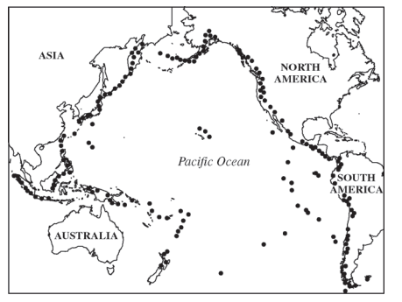
- FRQ sample- Plate tectonic theory states that the Earth’s lithosphere is broken into very slowly moving pieces or plates. Plate movements over vast stretches of time have led to the current orientation of our continents and oceans. Individual events along plate boundaries, such as earthquakes and volcanic eruptions, pose periodic threats to human activity and ecosystems. The “Ring of Fire” is a term that describes the location of increased seismic and volcanic activity around the margins of the Pacific Ocean basin. On the map above, each dot represents a volcano or an earthquake.
- Japan, Indonesia and the Philippines are examples of volcanic island chains that have formed along subduction zones between plates in the western Pacific.
- Describe what happens when two tectonic plates collide along a subduction zone.
ii. Explain how subduction leads to volcanic activity.

- Identify the following locations on the map above.
  - Area that exhibits island arcs
  - Area that exhibits a growing non-volcanic mountain chain due to uplift
  - Area where new crust is being created at a divergent plate boundary

- What causes seasons to occur in temperate zones?

- Describe how solar insolation shown at the right affects wind currents and precipitation patterns. 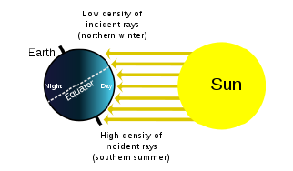

- On the world atlas below, label the following:
  - Equator
  - Arctic circle
  - Antarctic circle
  - Tropic of cancer
  - Tropic of Capricorn
  - Polar region
  - Temperate region
  - Tropic region
  - Northern Hemisphere
  - Southern Hemisphere
  - Label the major continents.
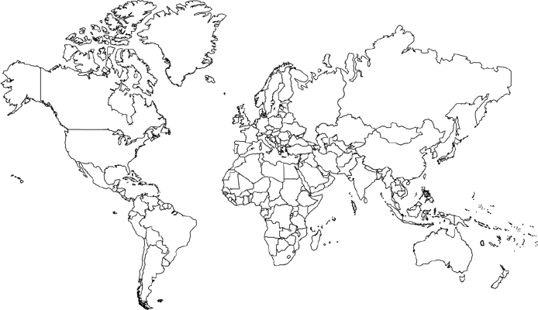

The Atmosphere
- Use the axes below for the following:
  - Draw a line representing the Earth’s atmosphere.
  - Label each layer of the Earth’s atmosphere and identify where the greenhouse effect occurs and the ozone layer is situated.

Altitude (km)
Temperature (°C)

- The box to the right contains a crude depiction of a mountain, use it to sketch and label the essential attributes of a rain shadow. Include labels for the direction of the prevailing winds and nearest ocean.

- Describe how the ocean currents, temperature and gas concentrations are directly related to those of the atmosphere.

- The acronym ENSO refers to _____________ _____________ _____________ _____________, a phenomenon that occurs in the _____________ Ocean.

- Describe the following diagram of the Coriolis effect. How does the solar intensity and atmospheric convection currents influence the location of the major biomes?
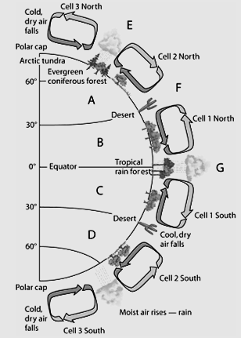

- Using the following diagrams, explain what an El Niño event is and why it is significant.

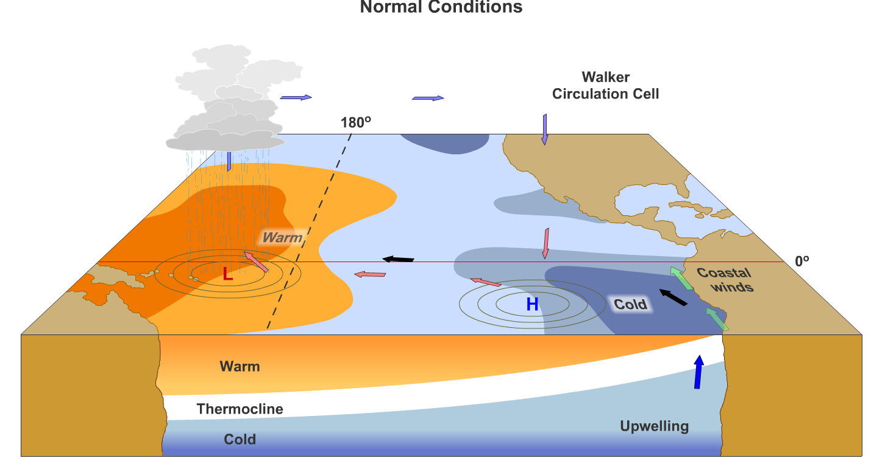
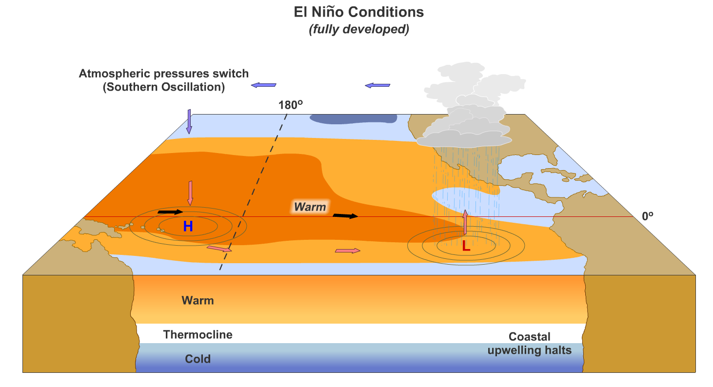

- How does the Richter scale work? What does it measure?

Type of Boundary | What happens? What can result? Give at least  one real world example. | Draw a picture
Divergent
Convergent
Transitional (Transform)

Soil and Soil Dynamics
- Explain the rock cycle. What are the three types of rocks and the forces that convert one form to another?

- Contrast the processes of weathering and erosion.

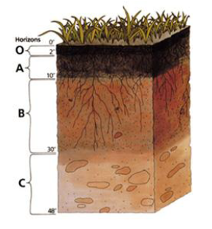
Which horizon do you find the following layers? Add in a description of each:

  - Eluviation layer _________

  - Top soil __________

  - Parent material _______

  - Sub soil ________

  - Leaf litter _____

- Identify the percent sand, silt, and clay for points (A) and (B) on the soil triangle below:
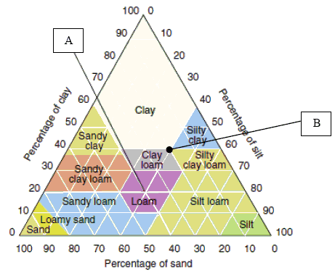

Identify three examples organic compounds and three examples of inorganic compounds.
(1)
(1)
Organic: (2) Inorganic: (2)
(3) (3)

- Arrange the following particles in order of smallest to largest: clay, sand, silt
(1) (2) (3)

- Explain how each of the following anthropogenic issues contribute to erosion
  - Agricultural practices
  - Urban development
  - River channelization
  - Deforestation
  - Mining

- Explain what human activities lead to
  - Desertification
  - Salinization
- What strategies can be used in the following issues to conserve soil nutrients while preventing erosion, desertification and/or salinization?
  - Agricultural practices
  - Urban development
  - River channelization
  - Deforestation
  - Mining

Unit 5: Land and Water Use 10-15%

Vocabulary

- agricultural revolution
- agroforestry
- alley cropping
- anthropocentric
- aquaculture
- aquifer
- arable land
- area strip mining
- bathyal
- benthos
- biomagnification
- bioaccumulation
- by-catch
- clear-cutting
- commercial inorganic fertilizer
- conservation
- conservationist
- conservation-tillage farming
- contour farming
- contour strip mining
- controlled burning
- conventional-tillage farming
- cost-benefit analysis (CBA)
- crop rotation
- desalinization
- Desertification
- Drainage basin
- dredging
- ecological restoration
- euphotic
- environmentalist
- environmentally sustainable economic development
- environmentally sustainable society
- erosion
- estuary
- euphotic zone
- eutrophic
- externalities
- CAFO
- fertility
- fertilizer
- fish farming
- fish ranching
- fishery
- food security
- fungicide
- Green Revolution
- genetically modified crops (GMO)
- Gentrification
- globalization
- herbicide
- high-input agriculture
- human capital
- industrialized agriculture
- insecticide
- integrated pest management (IPM)
- intercropping
- land degradation
- land-use planning
- long line fishing
- low-input agriculture
- intertidal zone
- macronutrient
- malnutrition
- mangrove forest
- mass transit
- maximum sustainable yield (MSY)
- mineral resource
- monocropping
- mountaintop removal
- Multi-Use Zoning
- natural capital
- natural recharge
- no-till farming
- old-growth forest
- open-pit mining
- ore
- organic farming
- overfishing
- overgrazing
- overnutrition
- pasture
- persistence
- pest
- pesticide
- plankton
- polyculture
- polyvarietal cultivation
- rangeland
- reforestation
- reserves
- restoration ecology
- salinity
- salinization
- second-growth forest
- selective cutting
- strip cropping
- strip cutting
- strip mining
- subsistence farming
- subsurface mining
- surface mining
- sustainable agriculture
- sustainable development
- sustainable living
- sustainable society
- tailings
- tar sand
- terracing
- thermal stratification
- tragedy of the commons
- undernutrition
- urban sprawl
- Urban Blight
- watershed
- water table
- wetland
- wilderness
- xeriscaping

Unit 5- Review Questions- Land and Water Use

A. Agriculture
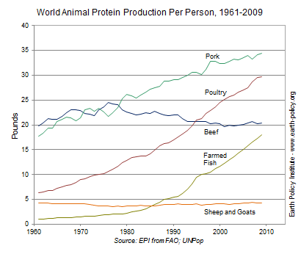
UUse the information in the diagram on the left, to answer the following:
  - T1. The percent change in the per capita global production of protein from poultry between 1980 and 2000 was approximately ________.
  - T2. The percent change in the per capita global production of protein from farmed fish between 1980 and 2000 was approximately ________.
  - T3. The percent change in the per capita global production of protein from beef between 1961 and 2009 was approximately ________.

  - Perform the following calculation. Show all of your work. If the grasses on a 100-hectare area of grassland grow at an average rate of 1 cm/day, the average volume of grass that is added to the grassland each day is ____________ m³. If the density of the grasses that grow in the grassland averages 400 kg/m³, the net primary productivity is approximately _____________ g/m²/day or _____________ g/m²/year.

  - The number of km² of Wilderness area increased from 4.0 X 10⁴ to 6.0 X 10⁴ in a decade. What is the percent increase?

  - Between 1950 and 2000, global meat production increased from 52 billion kilograms to 240 billion kilograms. During this period, the global human population increased from 2.6 billion to 6.0 billion.

    - Calculate the per capita meat production in 1950 and 2000

    - Use the values from part a to calculate the change in global per capital meat production during this 50-year period as a percentage of the 1950 value.

  - The acronym CAFO refers to _____________ _____________ _____________ _____________, which is important because:

  - What is different about growing plants hydroponically?

  - What was the Green Revolution and why is it important?

  - The acronym GMO refers to _____________ _____________ _____________, which is:

  - Arrange the following foods in order of highest to lowest in terms of global production: corn (maize); rice; wheat.
(1) (2) (3)

  - List four innovations that led to the Green revolution.
(1) (3)
(2) (4)
  - Explain what two issues can result from over- irrigation of crops in arid regions of the world.
  - What is a monocropping? What are two benefits of monocropping? What are two consequences?
  - Farmers in certain states lose 2.3 x 10² kg of topsoil in a year on average. There are 4.5 x 10³ farmers in this state. How much topsoil is lost in this state annually?

  - What is the Green Revolution? What are three implications of the Green Revolution?

  - Explain four methods of sustainable agriculture practices that help reduce erosion and desertification.
  - Contrast industrial versus integrated pest management strategies of controlling pests.

  - What are the main types of pesticides? What does it mean when a pesticide is persistent?

  - What is the pesticide treadmill?

  - How does pesticide resistance occur?

  - What is DDT? Why is it no longer used in the United States?
  - What are the costs and benefits of pesticides use?
  - What are the benefits of IPM? Why might people be hesitant to utilize IPM?
  - Explain what the FIRFA law protects you from.

B. Forestry
  - Perform the following calculations: (Show all of your work.) A rectangular area of forest that measures 20 thousand meters by 400 thousand meters has an area of ___________ square kilometers and ___________ hectares.

  - A 2500-hectare piece of wild chaparral was bought by a developer to turn into homes. The developer built homes on 1000 hectares and left the rest untouched. What was the percent decline in wild chaparral?

  - A company is importing rare tropical hardwood to manufacture furniture, list three laws, regulations, treaties, or acts that the company may have violated.
(1)
(2)
(3)
  - In terms of biodiversity, contrast the health of an old growth forest versus a tree plantation that has remediated a deforested region.

  - Describe the impact of natural forest fires on the health of a coniferous ecosystem. How have humans learned to manage controlled burns to maximize the fire’s benefits?

- 31.Describe the different methods of deforestation. Rank them from most damaging to forest health to least damaging.

- Explain how national forest land is managed by the US Forest service. Would you consider this land a common? Why or why not?

C. Rangelands
30. Explain how overgrazing can lead to desertification and a collapse of a grassland ecosystem. What methods are used to avoid this issue?

D. Other Land Use
31. For each of the following urban land development listed below, explain what issue(s) they create and what sustainable alternatives exist for each.
Urban land development | Issue | Sustainable alternative
Transportation infrastructure

Federal highway system

Canals and channels

- What economic and environmental issues are related to suburban sprawl?

- What is urban blight? Is it a positive or negative feedback loop? Explain.

- For each of the following public and federal lands, explain their purpose and challenges.
Public land | Purpose | Challenges
Wilderness areas

National parks

National Wildlife refuges

National Forests

Wetlands

Bureau of land management (BLM)

- Contrast the difference between the following land management techniques:
- Preservation
- Remediation
- Mitigation
- Restoration

E. Mining
- Explain where you find large reserves of the following mineral formations
- Coal
- Oil
- Natural gas

- Complete the following chart.
Mining Technique | Description | Environmental consequences
Open-Pit mining
Subsurface mining
Strip mining
Mountaintop removal
Drilling

- Strengthen this weak statement: “Mining causes pollution that may disrupt the environment.”

- What laws prevent mining issues such as acid drainage and the displacement of tailings?

F. Fishing
- ________________________ is a technique typically used to harvest scallops, crabs, and shrimp from the sea floor.

- Contrast the environmental impact of dredging, bottom trawling and longline fishing.

- What is the Tragedy of the Commons? How is it especially applicable to fishing?

- Why is overfishing such a difficult issue to solve in our oceans? Explain the solutions or alternatives related to sustainable fishing practices.

- Explain the pros and cons related to aquaculture.

- What relevant laws and treaties prevent overfishing and preserve ocean species.

- What is maximum sustainable yield? At which point on a population’s growth curve is it typically located?

- In a pasture of grass and other plants, the biomass of insects makes up 5000 kilograms. This is 5% of the total biomass of the pasture. What is the total biomass of the pasture? Set up the problem and solve below:

- Joshua trees in the Mojave Desert occupy 25% of a piece of land. The land has 450 hectares in total. How much land is made up of Joshua trees?

- Twenty percent of a forest is cut down. The forest area is 35,000 hectares. How many hectares of trees are left?

Unit 6: Energy Resources and Consumption

- Active solar heating system
- Anthracite coal
- Biofuel
- biodiesel
- biomass
- bituminous coal
- breeder nuclear fission reactor
- clean coal
- coal
- cogeneration
- commercial energy source
- control rod
- coolant
- containment structure
- crude oil
- decommissioned
- energy
- energy efficiency
- energy productivity
- energy return on investment
- fuel rod
- fracking
- geothermal energy
- half-life
- Hydroelectric
- LEED program
- lignite
- liquefied natural gas (LNG)
- liquefied petroleum gas (LPG)
- natural gas
- nonrenewable resource
- nuclear fission
- nuclear fusion
- oil
- oil sands
- oil shale
- ore
- passive solar system
- peak demand
- peat
- petrochemicals
- petroleum
- photochemical
- photovoltaic cells (PV)
- radioactive waste
- reactor
- refining
- renewable resource
- shale oil
- solar energy
- solar thermal systems
- spent
- subsidy
- subsistence energy source
- synfuels
- synthetic natural gas (SNG)
- tailings
- tar sand
- thermal mass
- tidal power
- turbine

Review Questions- Energy

A. Energy Concepts
      - A Honda Civic can go 348 miles on average before it runs out of gas. The tank holds 12 gallons of gas. What is the car’s mpg? (miles per gallon)

      - A 75-Watt light bulb that is used for an average of 4 hours each day uses ___________ kilowatt-hours of electricity per year.
Show work:

      - If the cost of gas is $2.50 per gallon and the average gas mileage of a car is 28 mpg, the cost of driving the car per mile is _____________ $/mi, or _____________ ȼ/mi.
Show work:

      - When energy that is stored in fossil fuels are burned, it changes form. Explain, using the law of thermodynamics, how energy forms change and what happens to it during the chemical change.

      - What is the formula for Energy Return on Investment (EROEI)? What does a larger EROEI value imply?

      - What is the capacity factor?
-According to the U.S. Department of Energy, a typical home in the United States uses approximately 900kWh of electricity per month/ How many homes can a 500 MW Power Plant with a 0.9 Capacity Factor support?

B. Energy Consumption
      - Explain how the major types of energy use have changed in the following historical circumstances:
- Industrial Revolution

- Exponential growth of developing nations

      - At present, what are the top five types of energy used globally?

C. Fossil Fuel Resources and Use

      - In the box to the right, list the ranks of coal in order from highest to lowest energy content. (indicate the direction in the box.)

      - List seven products that are derived primarily from crude oil:

      - Fracking is a common name for ______________ ______________ and it is a concern because…

      - The acronym ANWR refers to _____________ _____________ _____________ _____________, which is important because:

      - Perform the following calculations: (Show all of your work in a logical progression to the final answer.)
A family has a total of 1800 Watts of light bulbs throughout their house, if they replace them all with LED light bulbs, which use 80% less energy, the family will now use _____________ Watts of electricity.
Show work:

      - A space heater operates at 1600 Watts, if it is used for 10 hours each day for one week and the cost of electricity is 30 cents per kilowatt-hour, it will cost _____________ to operate the heater for the week.

      - A carmaker improved the mpg of a model of car from 22 to 32. What percent change is this?

      - What are the advantages and disadvantages to using biofuels?

      - On the following chart, summarize the environmental advantages/disadvantages of each energy source
Energy source | Advantages | Disadvantages
Nuclear

Hydroelectric

Solar electricity

Hydrogen fuel cells

Biomass

Wind energy

Ocean waves and tidal energy

Geothermal

D. Nuclear Energy
- Explain how nuclear fission works.

- Explain how uranium is used to make electricity in a nuclear power plant.

- What are the safety issues associated with nuclear fission? How do nuclear power plants reduce those risks?

- What happens during a nuclear melt down? What are the roles of control rods and circulating water?

- Explain what happened at Fukushima and why it is significant?

- State where Chernobyl is located and explain what happened there.

- Perform the following calculation. Show all of your work. A radioactive cloud may contain Iodine-131, which has a half-life of 8 days. If the waste must decay to a concentration of less than 0.1% to be considered safe, it will take approximately ______ days to reach safe levels.

- The half-life of Cs-137 is 30.2 years. If the initial mass of the sample is 100g, how much will remain after 120.8 years?

W
- What are the issues related to radioactive wastes? Explain the controversy surround Yucca Mountain as a waste disposal site.

- Contrast nuclear fusion and nuclear fission.

E. Hydroelectric Power
- In the box to the right, draw a diagram that illustrates how electricity is produced by a dam

- How are hydroelectric power plants used for flood control? What issues are related concerning flooding and sediment at dams?

- How do hydroelectric power plants affect salmon populations? What strategies do they use to account for this?

- What is tidal energy? Why isn’t it used more widely for electricity generation?

- Why is electricity referred to as a secondary energy source?

- Compare Combined Cycle and Cogeneration.

F. Energy Conservation
- List four things you could do to conserve energy.
(1)
(2)
(3)
(4)

G. Renewable Energy
- List two species that may be threatened by the construction of a solar power tower in the California Desert.
(1) _____ (2)

- ________________ is the active element in most photovoltaic cells.

- In the box below, sketch a house and the surroundings of a house that is designed to make the greatest use of passive solar energy in the northern hemisphere. Include, inside the box, the location of both the winter and summer sun, and labels to indicate the compass direction that the house faces.

- Perform the following calculation. (Show all of your work in a logical progression to the final answer.) A family has a 85 m² solar array on their house, which has an efficiency of 10%. If the average insolation on their array is 5 kWh/m²/day and their average cost of electricity is 30 cents per kilowatt-hour, the family has the capacity to produce _________ worth of electricity daily, and _________ annually, from the sun.

Unit 7: Atmospheric Pollution 7-10%

Vocabulary

- acid
- acid deposition
- air pollution
- biotic pollution
- broad spectrum agent
- carcinogen
- dose response curve
- effluent
- environmental degradation
- Environmental Protection Agency (EPA)
- environmental justice
- greenhouse effect
- greenhouse gases
- haze
- incineration
- industrial smog
- industrial waste
- nitrogen oxides (NOx)
- noise pollution
- nondegradable pollutant
- nonpersistent pollutant
- nonpoint source
- ozone (O3)
- ozone depletion
- ozone layer
- PANs
- particulates
- parts per billion (ppb)
- parts per million (ppm)
- parts per trillion (ppt)
- persistence
- persistent pollutant
- phytoremediation
- photochemical oxidant
- photochemical smog
- point source
- pollutant
- primary pollutant
- radon (Rn)
- risk assessment
- secondary pollutant
- smog
- stratospheric ozone
- sulfurous smog
- temperature inversion
- thermal inversion
- toxicity
- toxicology
- tropospheric ozone
- volatile organic compounds (VOCs)

Pollution Review Questions

Air pollution

- What are primary pollutants?

- What are secondary pollutants?

Complete the chart of air pollutants below:
Compound | Symbol | Human-Derived Sources | Effects/Impacts
Sulfur Dioxide
Nitrogen Oxides
Carbon Monoxide
Particulate Matter
Lead
Ozone
Volatile Organic Compounds
Mercury
Carbon Dioxide

Identify significant sources of the following air pollutants. Indicate if they are primary or secondary pollutants:
Formaldehyde:
Radon:
Mercury:
Carbon monoxide:
Nitrous oxide:

Name the following:
SO_{X} N₂
NH₄⁺ NO_{x}
  - NO₂ is converted to N₂ and O₂ in a _____________ _____________, which also converts _____ to _____.

  - Explain the causes of an urban heat island.

  - In the area below, write a series of chemical reactions that leads to the formation of tropospheric ozone in photochemical smog.

  - For each of the following substances, draw an arrow that points to an unambiguous location along the line, below, representing pH: orange juice; normal rain; ammonia; lime (calcium carbonate); sulfuric acid; acid rain; human blood.

1 2 3 4 5 6 7 8 9 10 11 12 13 14
pH
  - Explain the cause of acid deposition and its major environmental effects

  - How are heat islands and temperature inversions formed? Why are they concerns related to smog?

  - Explain how ozone is “good up high but bad nearby”.

  - Why is indoor air pollution the most unregulated form of air pollution? What sources of indoor air pollution are the biggest issues?

  - Explain the remediation and reduction strategies for controlling radon in the home.

  - Explain the main components of the Clean Air Act and other relevant air pollution laws

Noise pollution
  - What are the sources, effects and control measures of noise pollution?

Must-Know Math Review
Things to know…..  Million= 10⁶  Billion= 10⁹  Mega= 10⁶ (ex: 1,000,000 BTU/ 1 MBTU)  Kilo= 10³ (ex: 1000 watts/ 1 kW)  Half Life  1 1/2 1/4 1/8 1/16 1/32 1/64 | Population Stuff….  Approximate population for:  The world: 7.5 billion  China: 1.3 billion  India: 1.3 billion  The US: 325 million  Per Capita = Per Person
Percent  Percent is part divided by the whole times 100!  Primary Productivity  Gross primary productivity - respiration = net primary productivity | Population Math  Population Density=  Number of individuals/ area  Growth Rate is a %  B-D/ population size * 100  Rule of 70  DT = 70/ GR
Percent Change  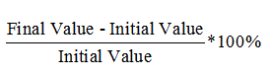  N-O  O | ENERGY  KWh= kilowatts * hours  Efficiency can be solved using ratios
ALWAYS! EVERYTIME!
SHOW YOUR WORK!
Numbers must be labeled in the SET-UP (Use dimensional analysis!)
Your numbers will be neat!
If you can’t use scientific notation, count your zeroes when you multiply and reduce them when you divide. Double check!!
Always make sure your answer makes sense!
Label and identify your answers clearly!
