Chapter 11 Death: Meaning, Manner,
Mechanism, Cause, and Time
Real CSI: Crime Autopsy Notes

Pig Decomposition Notes

The Body Farm Notes

The Definition of Death
- In the 17th Century, before the ________________________________, anyone in a coma or a slow heart rate was presumed dead and was buried.

- Cessation, or ________________________________________

  - Irreversible cessation of blood circulation
  - Cessation of all brain activity
  - ________________________________________________________________________

- Autolysis-
The manner of death can be
- Natural, the most common, caused by interruption and failure of body functions resulting from age or disease
- _______________________________________
- Suicidal
- ______________________________________
- Undetermined
- ______________________________________________________________________________

What is the Manner of Death in these cases?
- A man with a heart condition is attacked and dies from a heart attack during the assault.

- An elderly woman dies after being kept from receiving proper health care by her son.

Cause and Mechanism of Death

Cause of the death is …

Proximate cause of death …

Mechanism of death …

**usually only “Cause” and “Mechanism” are listed on the death certificate**

Time of Death- Livor Mortis
The Color of Death
- Lividity—

- Lividity begins about ___________ hours after death
- Discoloration becomes permanent after _____________ hours
- Ambient temperature affects the ________________of decomposition
- Lividity can determine the position of the body during the first _______________hours
- Dual lividity could occur if the body was kept in one position ___________________ hours after death and then moved to a second position before the lividity became permanent.

Time of Death- Rigor Mortis
The Rigidity of Death (Stiffness)
- Without oxygen in the blood—

- Starts in the ___________ and expands throughout
- Begins after 2 hours
- After about 15 hours—

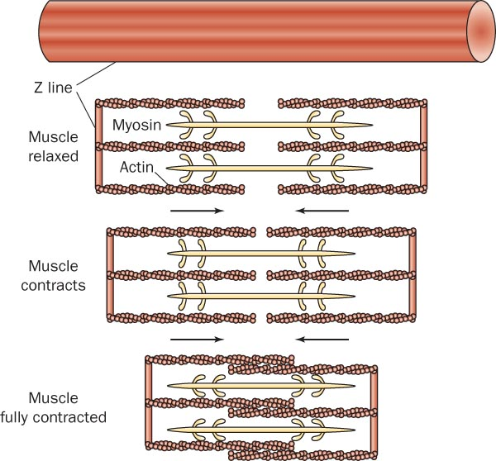

Explain this picture:
Observation | Approx. Time Scale
The body is at its most rigid state
Less than 2 hours
or more than 48 hours ago

Factors affecting rigor mortis:
- Ambient temperature

- General health of person at time of death

- Sun exposure

Time of Death- Algor Mortis
Death heat (describes temperature loss)
- Body heat falls after death
  - About 1.5 degrees per hour immediately after death

  - Heat loss is affected by the ambient temperature

- Time of death is expressed as a range of time
State of Contents | Timing of Death
Undigested food present in the stomach | Zero to two hours after the last meal
Stomach is empty, but food found in small intestine | Death occurred at least four to six hours after a meal
Small intestine is empty; waste found in large intestine | Death occurred 12 or more hours after a meal

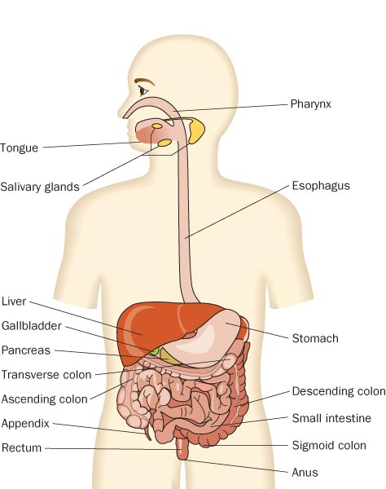

Time of Death- Stages of Decomposition
- Fluids begin to leak from body openings as cell membranes rupture
- Discoloration of the face
- The skin sloughs off
- The skin blisters
- Green and purplish staining from blood decomposition
- The corpse bloats
- Eyeballs and other tissues liquefy
- The abdomen swells
- Marbling appearance on the skin

*The speed of decomposition depends on the person’s:
1) 2) size of body 3) nature of death 4)

Dirty Jobs- Decomposition Notes:

Time of Death- Insects
Forensic entomologist
  - Collects insect evidence from on, above, and below the body

- As the corpse decomposes, other kinds of insects arrive

Time of Death- Blowfly Life Cycle
- <8 hours after death—blowfly eggs can be found in the moist, warm areas of a corpse
- Within 20 hours—1st of their 3 larva stages
3. 4th or 5th day—3rd of their 3 larva stages
- 8 to 12 days—larvae migrates to a dry place
- 18 to 24 days— Early pupa; immobile; changes from light brown to dark brown
- By the 21st-24th day the pupa cases will split open and adult blowflies will emerge.

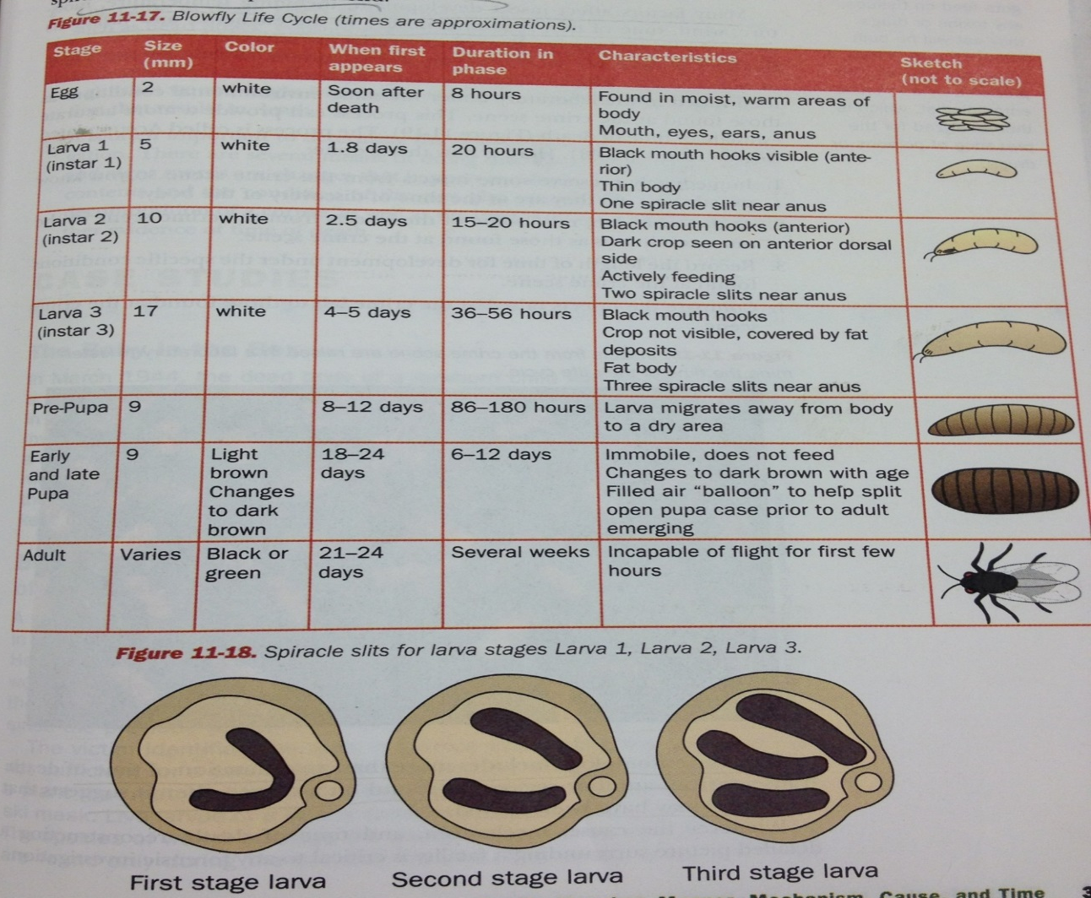

Insect Timeline
- 1.8 days First Stage (instar 1) V-shaped
- 2.5 days Second Stage (instar 2) two spiracles
- 4-5 days Third Stage (instar 3) three spiracles
Accumulated Degree Hours (ADH)
- Immediately preserve some insects from the crime scene.
- At the crime lab, raise some of the insects from the crime scene in the same conditions as those found at the crime scene

3.

4.

- The insect life cycle provides scientists with a benchmark to estimate a time of death
- Insect evidence cannot provide:
*
*
* Insect evidence provides a close estimate and may provide proof that the corpse has been moved.

Summary:

