Finger Prints Intro- http://www.crimescene-forensics.com/Fingerprints.html
8/27/15
Loop Pattern:
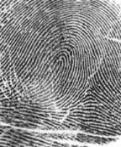

Whorl Patterns:
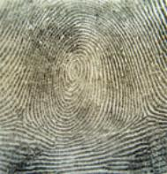

Arch Patterns:
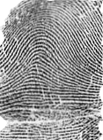

Type Lines:

Delta:
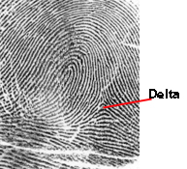
Classification of Fingerprints:

Individual Evidence:

