Name ________________________________________________ Date_______________
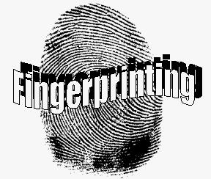
This is to be done independently. I will collect this in 5 minutes.
What did the synthetic fibers do in the flame?

What did the natural fibers do in the flame?

What did hair do in the flame?

Name 2 Bunsen Burner Safety Procedures.

What happened in lab yesterday that would have been bad news for anyone without their hair up?

What are the types of fingerprints that we learned about yesterday?

News Article:
What site did you find it?

Summarize the news article.

How could you relate this to Forensics?

