Project: Your Own CSI Episode
Due:
Name ____________________________________Date _____________________
Your Group Members:

Rubric (Everyone in your group will get equal points!):
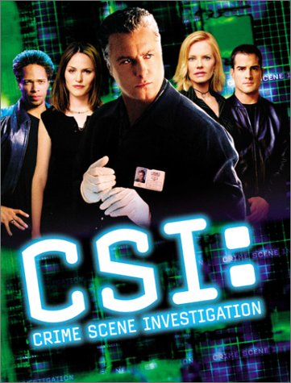
Equal Group Participation:
1 2 3 4

Video/Similar to CSI TV Episode:
1 2 3 4

Creativity
1 2 3 4

Approaching of Crime Scene:
1 2 3 4

Explain who the suspects are and why they are suspects (possible hair, fiber, or eyewitness evidence):
1 2 3 4

Explain/Show How Fingerprints Were Collected (Dusting):
1 2 3 4

Match one of the Suspect Prints to Crime Scene Print Using Fingerprint Analysis (Ten Card): Use terminology (Delta, Ridge Structures, Core, Type, Latent, etc.)
1 2 3 4

Video is Between 7 and 10 Minutes Long:
1 2 3 4

