Name __________________________________________ Date______________________
Notes on Fingerprints

Fingerprints History and Analysis

- “Every human being carries with him from his cradle to his grave, certain physical marks which do not change their character, and by which he can always be identified– and that without shade of doubt or question. These marks are his signature, his physiological autograph so to speak, and this autograph cannot be counterfeited, nor can he disguise it or hide it away, nor can it become illegible by the wear and mutations of time.”

History of Fingerprints

- - Used in Babylon (1792-1750 B.C.) when fingerprints were pressed into _____________________________________________________________________
- - Ink fingerprints used in Ancient China on all ________________________________
- 1684- ___________________________wrote a paper describing the patterns he saw on human hands under the microscope including the presence of ridges.
- 1788- _______________________________ described that the arrangement of ridges never duplicated in two persons.
- 1823- Jan Evangelist Purkyn described 9 distinct fingerprint ____________________.
- 1856- Sir William Herschel began collection of fingerprints and noticed they were not _____________________________________________________________________
- 1879- Alphonse Bertillon created system for identification of criminals (Bertillonage) and 1902 he was credited with solving the first murder using fingerprints.
- 1891- _________________________________improved fingerprint collection by collecting all 10 prints.
- 1896- Sir Edmund Richard Henry created _____________________________________.

What are Fingerprints?
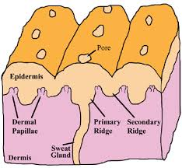

Types of Fingerprints
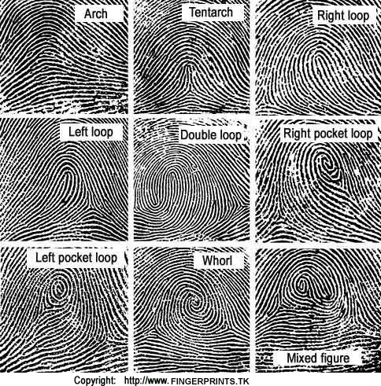
Percentages
Whorl-

Arches-

Loops-

Delta, Core, and Ridge Lines
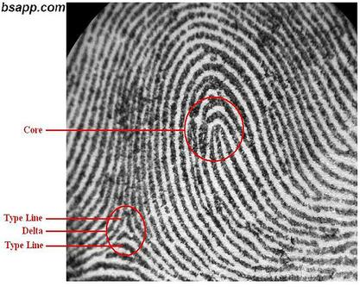

Ridge Patterns are also called ____________________________________________
How many individual ridge characteristics are there on the average fingerprint? _____________

Types of Fingerprints
Patent Fingerprints:

Plastic Fingerprints:

Latent Fingerprints:

Can fingerprints be altered or disguised?

How reliable are fingerprints?

How are fingerprints analyzed?

How are latent fingerprints collected?

Fingerprint Analysis Techniques

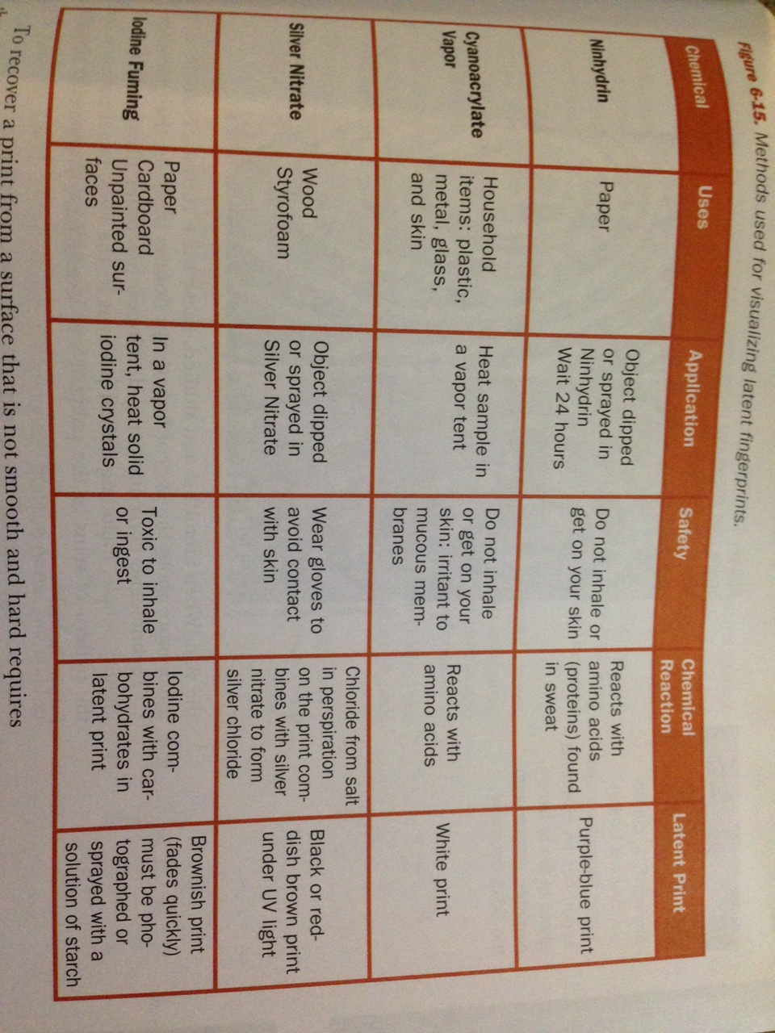

The Future of Fingerprinting
