Forensic Anthropology Notes
What We Learn From Bones

- Adults Have _______ Bones
- Babies Have _______ Bones
  - Bones fuse as we develop
- Axial Skeleton
_____________________________________________________________________________________________________________________________________________________________
- ______________________
  - Pelvis, arms, legs, etc….

- Sacrum
  - ____________________________________
  - Coccyx at end = tail bone
- Pelvis =
  - Ileum
  - ___________
  - Pubis (pubic bones)

- Osteoblast cells (osteocytes)—_________________________________________
  - Skeleton starts out as cartilage
    - Ossification—

  - Starts to turn to bone after a few weeks of in utero development
  - At 8 weeks a skeleton is visible with x-ray
  - Process continues throughout lifetime.
- Life Cycle of Bone- _________________________________________________
    - Osteoclasts—______________________________________________________
    - Osteoblasts – ______________________________________________________
- The skeleton has completely replaced itself every __________

Compare and Contrast
Osteoblasts and Osteoclasts

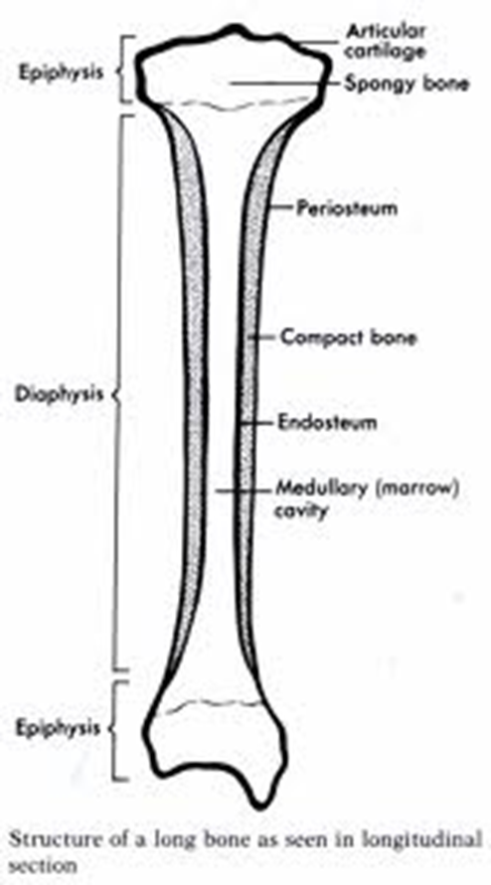
- Periosteum
  - Protective membrane or covering
  - Contains blood vessels and nerves
  - keeps bones moist
  - Aids in recovery from injury
- Epiphysis-
  - the ends of the bone
  - Epipyseal (growth) plates located here
    - Cartilaginous areas
    - Close during stages of life a filled with bone
- Diaphysis-
  - the shaft or long middle portion of bone
- Spongy Bone
  - NOT ACTUALLY SPONGY
  - More porous, located in/on epiphysis
- Compact Bone
  - Stronger bone of diaphysis
  - Contains cavity
- Medullary cavity
  - Contains bone marrow
    - Where blood cells are produced

What Protects the Ends of Bones?
- Articular cartilage—
  - Think chicken wing
  - Does not regenerate
    - Age
    - Injury
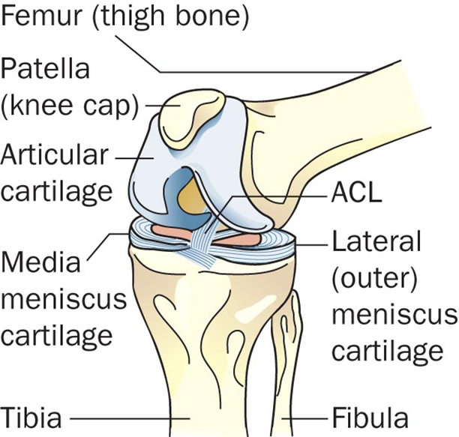

What Connects Bones?

- ligaments—
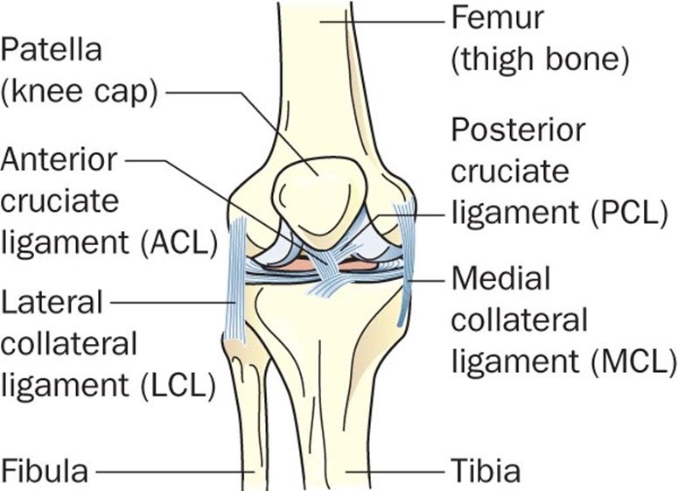

How Do Bones Move?
Muscles-

Tendons-

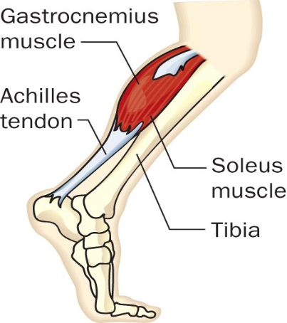

Forensic Anthropology
- Studies the identifying characteristics of the remains of an individual
  - SKELETON
- So what can a skeleton tells us?
  - Sex
  - Height
  - Race/Ethnicity
  - Physical Health and/or History of Disease
  - Identification
    - Dental Records
    - Mitochondrial DNA

Distinguishing Males From Females
OVERALL SKELETON
  - Female Skeleton

  - Male Skeleton

      - Male hormones = more muscle development
      - Surface of bone where tendons attach is thicker

Sex Determination
SKULL
Male Characteristics | Trait | Female Characteristics
More square | Shape of eye | More rounded
More square |  | More V-shaped
Thick and larger | Upper brow ridge

Male Characteristics | Trait | Female Characteristics
Present | Occipital protuberance | Absent
Low and sloping
Rough and bumpy | Surface of skull | Smooth
 | Ramus of mandible | Slanting
Rough and bumpy | Nuchal crest

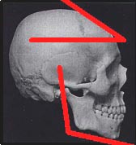
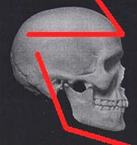

- Is the female skull smoother than the male’s?

- Which frontal bone is lower and sloping?

- Are the male’s eye orbits more circular?

- Which jaw is more square, with an angle that is closer to 90º?

Sex Determination
PELVIS

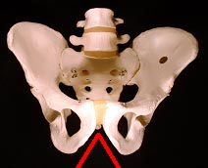
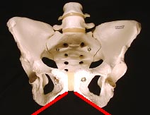

- An easy method to determine gender
- The surface of a woman’s pelvis can be scarred from pregnancy/child bearing
- The sub pubic angle of the female pelvis is greater than 90º; the male’s, less
- Pelvic cavity
  - __________________________________________________________________
  - __________________________________________________________________

- The male femur is thicker and joins the pelvis at a straighter angle than the female femur
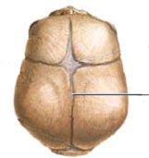
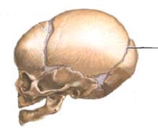
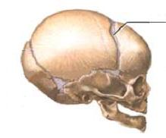
Age Determination
SKULL
- LAMBOIDAL SUTURE
    - _____________________
    - _____________________
    - _____________________

- SAGITAL SUTURE
    - Closes by about age 32
    - CORONAL SUTURE
Closed at about age 50

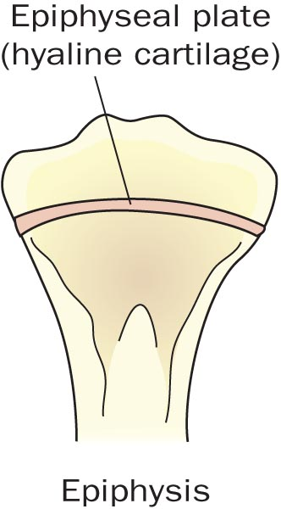
Age Determination
LONG BONES

- At birth—450+ bones in the skeleton

- Epiphysis line—appears where
cartilage is replaced by bone

- This information can be used to
approximate a skeleton’s age

Height Determination
- Measurements of LONG BONES like the humerus and femur can be used to calculate a persons height
  - Involves calculations
    - Example
      - 2.10 x (length of femur in cm) + 72.22 cm = height of person in cm.
        - + or – 3.91 cm (about an 1 ½ inches)

- Shape of eye orbits
  - Caucasoid = rounded, somewhat square

  - Mongoloid = rounded, somewhat circular
- Nasal Spine

  - Negroid = very small spine
  - Mongoloid = somewhat prominent spine

- Nasal Index
  - Caucasoid = <.48
  - Negroid = >.53

- Prognathism
  - Caucasoid = straight

  - Mongoloid = variable
- Femur

  - Negroid = fingers do not fit under curvature
  - Mongoloid = fingers fit under curvature

Identification
- Dental records

- Facial Reconstruction

DNA and Identification
- Bone contains little nuclear DNA but it does contain _______________DNA
- Nuclear DNA __________________ before mitochondrial DNA
- Mitochondrial DNA is inherited only from the _____________
- Compare results with living relatives on the mother’s side of the family

Right vs Left Handed
- Bones are usually more developed on the side that is used most
- Sometimes there may also be more deterioration.

History of Disease / Prior Surgeries

- Osteoporosis
- Arthritis

  - Rods, plates ect..
    - Have id number

Skeletal Trauma / Cause of Death
- Sharp Force Weapons, Blunt Force Trauma, Gunshots

  - Blunt force generally more widespread fractures and greater damage to bone than sharp objects

