Glass and Refraction Notes
Speed of Light:

Two models describe the behavior of light.
  - Light is described as a continuous ____________ traveling through space.
  - Light is also described as a stream of discrete energy ______________.
___________ are described as _______________ that release energy in the form of electrons
___________ are described in terms such as:
-_________________, the distance between two successive crests (or one trough to the next trough).
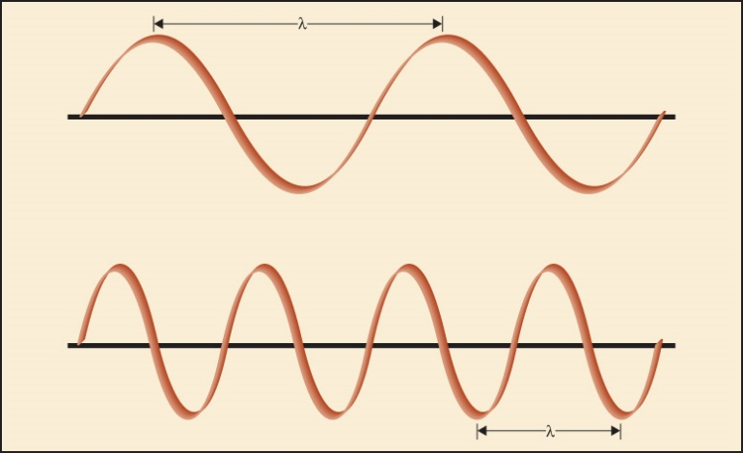
  - __________________, the number of crests passing any one given point per unit of time.

Visible Light: When __________________________________________________________________, it is dispersed into a continuous ________________________________________________.
Visible light ranges in color from red to violet in the electromagnetic spectrum (ROYGBIV).
Physical Properties of Light
- Light waves travel in ______________________________________________________ until they hit another substance.
- Contact with another substance _______________________________causes the light wave to slow down, causing the ray of _____________________________________
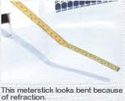

Refraction:

Refraction Index:
A ________________________________________________________________________ as it travels from one medium into another

Refraction Index=

Water has a Refractive Index of:

RI depends on ____________________________________________________________________________________________________________________________________________________________

Refractive Index by Immersion:
Liquid | RI | Glass | RI
Water | 1.333 | Vitreous silica | 1.458
Olive oil | 1.467 | Headlight | 1.47-1.49
Glycerin | 1.473 | Window | 1.51-1.52
Castor oil | 1.82 | Bottle | 1.51-1.52
Clove oil | 1.543 | Optical | 1.52-1.53
Bromobenzene | 1.560 | Quartz | 1.544-1.553
Bromoform | 1.597 | Lead | 1.56-1.61
Cinnamon oil | 1.619 | Diamond | 2.419
1. A glass particle is ________________________________________ (silicone oil) which has a different refractive index compared to the glass
2.A _____________________ is present. It is a __________________________________ ____________________________________________ that is immersed in the oil of a different refractive index.
3. When the ______________________________________, the Becke line disappears and : RI oil = RI glass. The glass appears to disappear

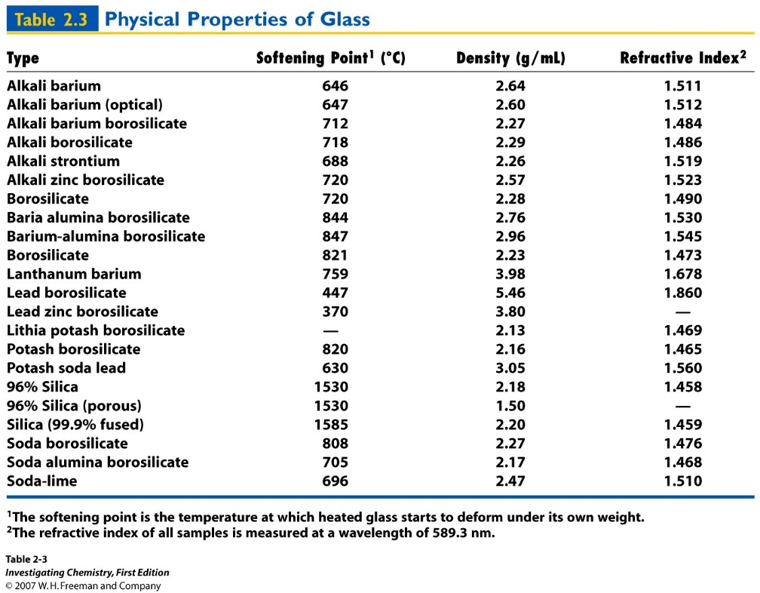

The __________has compiled density and _____________________________ for glass from around the _______________.

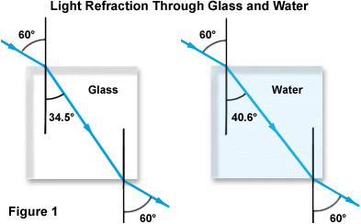
N= N=
The _____________________ the ______, the more the light bends.

Learning Check:
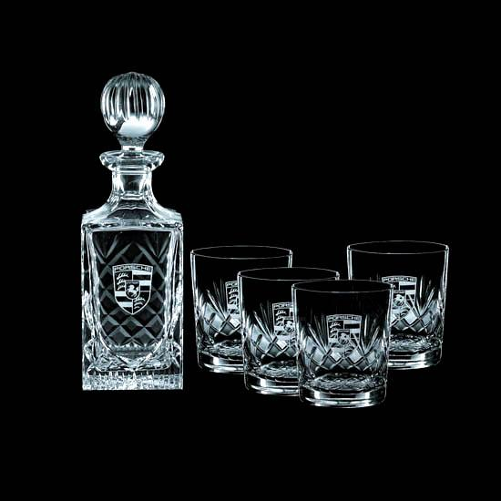
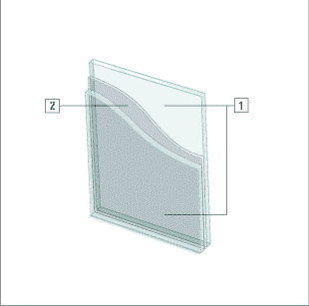
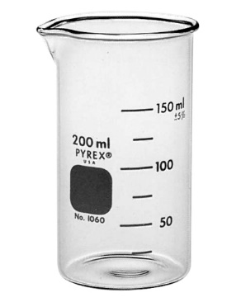
Beaker Windshield Crystal

