Glass Notes
Case Study: Susan Nutt (1987)
At 9:30pm on a cloudy, dark night in February, 19-year-old Craig Elliott Kalani went for a walk in his neighborhood in northwest Oregon but never returned home. A hit-and-run driver killed him. Crime-scene investigators collected pieces of glass embedded in Craig’s jacket and other glass fragments found on the ground near his body.
Police searched for a vehicle that had damages consistent with a hit-and-run accident. They found a car with those types of damages that belonged to a woman named Susan Nutt. In order to connect Ms. Nutt and her car with the crime, the police had to match the glass from the crime scene to the glass in her car. The scientists found that windshield glass from the crime scene contained the same 22 chemical elements as those used to make the glass in Ms. Nutter’s car. The scientists considered both samples of glass to be a definite match.
The glass evidence helped convict Susan Nutt of failure to perform the duties of a driver for an injured person. She was sentenced to up to 5 years in and prison and 5 years’ probation.
Physical vs. Chemical Properties
The forensic scientist must constantly determine those properties that give distinguishing characteristics to matter, giving it a unique identity.
Physical properties:

Chemical properties:

Forensic Examination of Glass
Goals:
1.
2.
3.
4.
Compare physical and chemical characteristics:
- Optical properties: ____________________________________
- Non-optical properties: ____________________________________________________________________________________________________________________________________________________________________
- Chemical properties: ______________________________________________

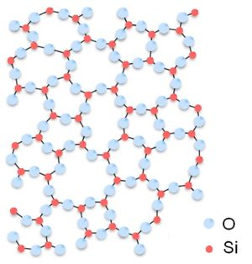
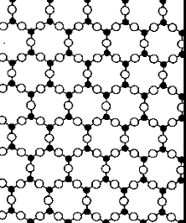
Structure:
Amorphous Structure: Glass
Crystalline Structure: Salt (NaCl)
Glass is Amorphous
Amorphous:

Example:
Physical properties:

Chemical Properties:

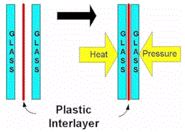
What Other Types of Glass Are There?
Laminated Glass:
Tempered Safety Glass:

Glass In Forensics
Used in solving _____________________________________________________________________________________
Glass is a type of transfer evidence and can be _____________________________________________.
Only can individualize a glass fragment, if can fit it like puzzle piece to its source

Collection of Glass
If even the remotest possibility exists that glass fragments may be pieced together, every effort must be made to collect ________________________________________________________.
When an individual fit is thought improbable, the evidence collector must submit all glass evidence found in the possession of the suspect along with a representative sample of broken glass remaining at the crime scene.
The glass fragments should be ___________________________________________ to avoid further breakage.
If the suspect’s shoes and/or clothing are to be examined for the presence of glass fragments, they should be ______________________________________________ and transmitted to the laboratory.
Glass Examples
Can glass be shattered with your voice?

Glass Transfer Evidence
Glass flies __________________________!
How Do Glass Windows Break?

- Glass acts initially as an elastic surface and bends away when a force is applied. When the force increases beyond its tensile strength, it cracks.

Because of a lack of order and pattern, glass breaks in random patterns
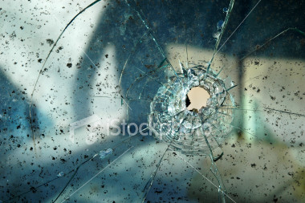
An impact in glass produces two types of fractures
Radial __________________________________________
Concentric ______________________________________

Projectile Patterns
Small projectiles passing through glass at a high velocity will produce characteristic patterns
__________________________________________________________________________________________________________________________________________________________________________A bullet will create an exit hole that _______________________________ than entry hole
Lower velocity impacts may not penetrate the glass but leave only a pit or crater on one side of the glass

Which Bullet Hole Was First?
Determining which bullet hole in glass was created first:
- ________________________________________________________________
- cracks radiating out from the hole will stop when they encounter another crack
Putting it Back Together Again?
- Because glass is ___________________________, no two glass objects will _______________________________________________________________.

Glass Fragments
For the forensic scientist, the problem of glass comparison is one that depends on the need to find and measure those properties that will associate one glass fragment with another while minimizing or eliminating other sources.
To compare glass fragments, a forensic scientist evaluates two important physical properties: density and refractive index.

Density
Mass per unit volume
Density=

Remains the ________________________________________________________________
Why Measure Density?
Can be used as a ___________________________________________________________________.
Useful in identifying ________________________________ present in the known and/or questioned samples.
It is ______________________________ and an intensive property (not dependant on sample mass).
Need to measure very precisely in parts per hundred or thousand or better.

Glass Density
- Density can be measured by:
  - ____________________________________ and volume (usually by water displacement)
  - comparison by flotation. The glass can be __________________________to other relevant pieces of glass which will _______________________________________________________________________.

