Names/Members _____________________________________________________________
Purpose: Design a SAFE way to break, observe, record and measure the properties of glass:
You will be making a poster for this project. It must include
- Drawing of design.
- Presentation of your glass piece. Label at least 5 important fractures/anomalies.
- Calculation of the force required to break window glass for a free falling object. F=ma
- Density of object. D=m/v
5) Your group will present next week in a “silent museum”

Planning:
1. Safety precautions must be cleared by your instructor before you build it. Decide if you need to temper it.
2. Fill out the scientific method outline up to Results/Conclusion.
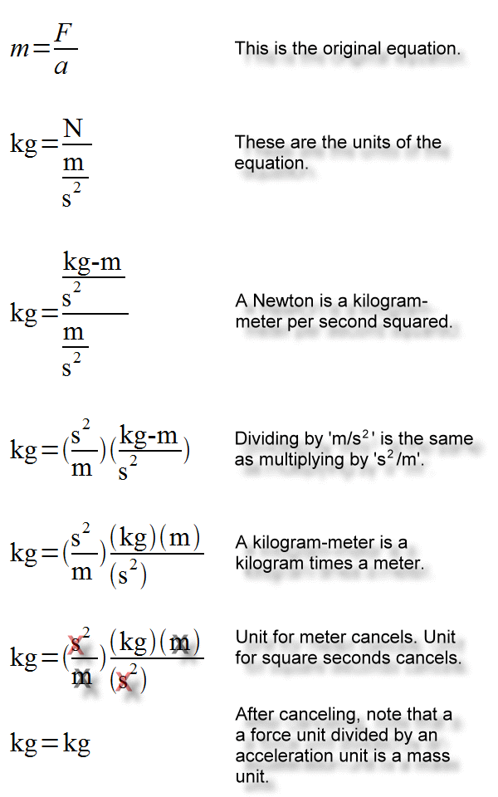
3. Decide what materials you will need for tomorrow.

Planning:

