Hair Warm-Up
- Label the three parts of this hair. (Cuticle, Follicle, Medulla, Cortex)

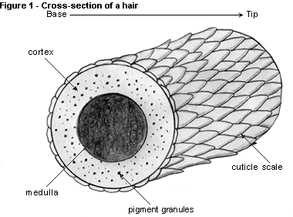

- What kind of information can hair provide for us at a crime scene?

- Name six different kinds of hairs that can be found on the body.

- Do you think hair continues to grow after death? Do you have a better explanation? What?

- What is the part of the hair responsible for color?

