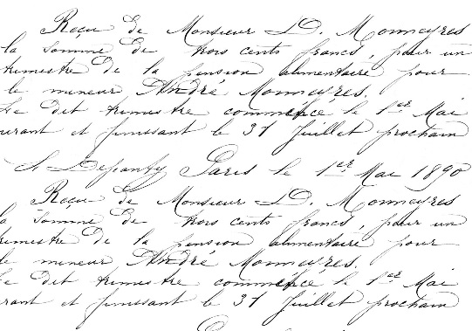
Name ______________________________________________________
Lab on Handwriting Analysis

Miss Jones has been murdered! A ransom note was left. It said:
“Ransom:
I have killed Molly Jones on 10/21 and have decided to take her dog, Banjo, hostage. I will not return the beloved dog to her family unless they pay $5,000. They will never see who I am. They are instructed to leave the cash in their mailbox, and I will leave the dog there in a box. If I see any police or people around, I will kill the dog.”

Problem:
Figure out who did it and prepare an expert testimony for the court. There are 4 suspects.

Design an Experiment: (How should you go about doing this as a forensic investigator?) Bullet the steps. Assume that you have access to the suspect and victim’s houses.

Hypothesis: (If/Then)

Procedure:

Data:
You are going to court. How are you going to present this data in a “jury friendly” way? Hint: Make a table and then a frequency bar graph. Make sure to label the axis.

Results and Conclusion: (who done it?)

Expert Testimony:
Introduction:

Data:

Results and Conclusion:

