Name _____________________________________________________
Real Money Observations!
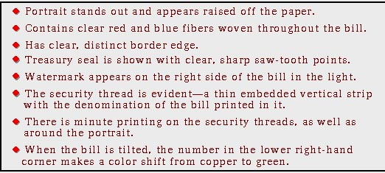

Your Observations for Each of the Bullet Points:
Portrait:

Red and blue fibers woven throughout the bill:

Border Edge:

Treasury Seal:

Watermark:

Security Thread:

Minute Printing:

Number is lower right-hand corner:

