Name ________________________________________________
Describe each of these pictures to the best of your ability. You may use your notes.

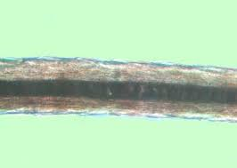
______________________________________________________________________________________________________________________________________________________________________________________________________________________________________________________________________________________________________________________________________________________________________________________________________________________________________________________________________________________________________________________________

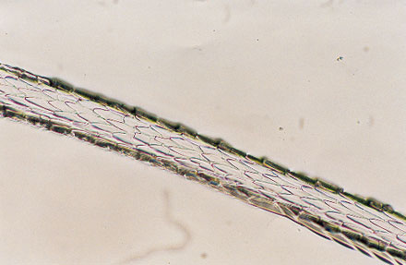
______________________________________________________________________________________________________________________________________________________________________________________________________________________________________________________________________________________________________________________________________________________________________________________________________________________________________________________________________________________________________________________________

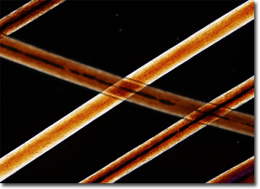
______________________________________________________________________________________________________________________________________________________________________________________________________________________________________________________________________________________________________________________________________________________________________________________________________________________________________________________________________________________________________________________________

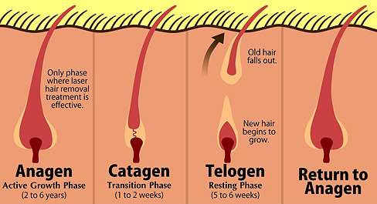
______________________________________________________________________________________________________________________________________________________________________________________________________________________________________________________________________________________________________________________________________________________________________________________________________________________________________________________________________________________________________________________________
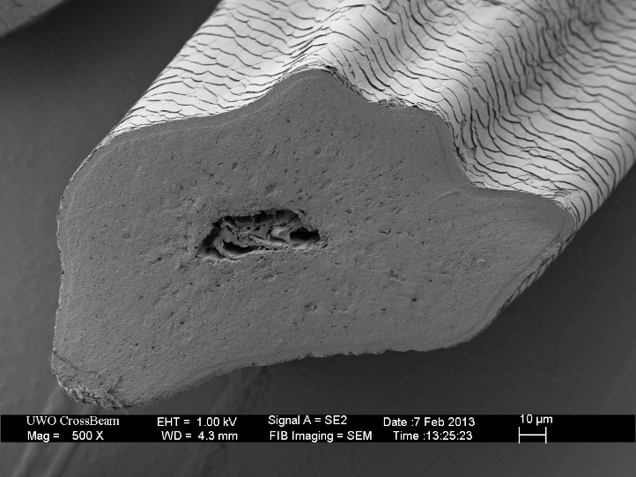 (TRIANGULAR CROSS SECTION)
___________________________________________________________________________________________________________________________________________________________________________________________________________________________________________________________________________________________________________________________________________________
