Name ____________ Block _______

Personal Energy Use Audit

On the chart below, record the amount of time you use these appliances each day. If you use them only a few times a week or less, pro rate them to a daily use. Convert the watts of power to kilowatts and multiply by the time used to get kilowatt-hours/day. If you use electrical appliances that are not on the list add them in the spaces provided and determine the watts by multiplying the volts by the amps on the appliance label.

DIRECTIONS: Answer the questions below in the space provided. Let's calculate the annual cost to run an appliance for a year.

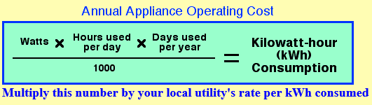
The average rate for Cobb County is 8.9₵ per kWh

EXAMPLE
If John uses a fan (200 watts) 4 hours a day for 120 days per year, how much does it cost him to run his fan per year?

200 X 4 X 120 = 96 kWh
1000

96 kWh X .089 Cents/kWh = $8.54 per year

Now complete the chart on the backside:

Concluding Questions:

1. How much electrical energy do you consume each day, on an average?

How much would that be each year?

2. Assume everyone in your household uses the same amount of electrical energy per day as you. Multiply
this by the number of people in your family by your total for the year and compare the total to the value on your gas bill from Public Service Gas and Electric. How do the numbers compare?

3. What is the percent difference?

Why do you think there is a difference?

How could we have redesigned the exercise to account for the error?

4. What can you and your family do to cut your energy use by at least 20%?
Make at least 3 reasonable suggestions.
1.

2.

3.

Complete the Table Below:

Appliance | Watts | Hours a day | Days per week  (hours x 7) | Days used per year  (____x 52) | Kilowatt Hour (kWh) Consumption per year  = (watts x hrs x days)/1000) | Cost per year  (kWh x .089)
A/C - window | 1360
A/C - central | 3500
Clothes washer | 512
Clothes dryer | 5000
Refrigerator | 795
Coffee maker | 1100
Oven | 2400
Microwave | 750
Toaster | 1100 | .20
Computer | 60
Radio/Stereo | 70
Television | 90
DVD/BluRay Player | 50
Hair dryer | 1200 | .10
Iron | 1100
Vacuum cleaner | 650
Lamps/Lights | 75
Wifi router | 6
Cell phone charger | 5 | 3
Cell phone charger plugged in but not in use | .3
Video Game Console | 90
Printer – in use | 40 | .15
Water heater | 4000 | 3
Oven | 2400 | 1

Total Cost
=

