Name: ______________________ Period:
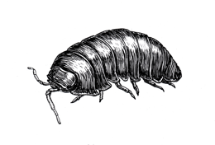

Determining the Ranges of Tolerance for Pillbugs

Objectives:
- Demonstrate applications of the scientific method
- Design and conduct an experiment on how abiotic environmental factors affect organisms.
- Construct a range of tolerance for a specific abiotic factor through an experiment you design and conduct.
Terms and Concepts:
- Abiotic factors
- Biotic factors
- Confounding variables
- Experimental design
- Habitat
- Range of tolerance
- Scientific method

Background:
Species vary in their resource needs and tolerances. The environment consists of biotic (living) and abiotic (nonliving or physical) parts. Within a given ecosystem, whether it is the Mojave Desert or the Arctic, each population of a species has a range of tolerance—the environmental conditions that a species can tolerate. Individuals within a population may also have slightly different ranges of tolerance for any environmental condition. Certain organisms are slowly changing locations due to changing environmental factors; animals are usually able to do this at a faster rate than plants, but even trees will shift their range in response to stresses. Species that have narrow ranges of tolerance are the most vulnerable to rapid environmental changes.

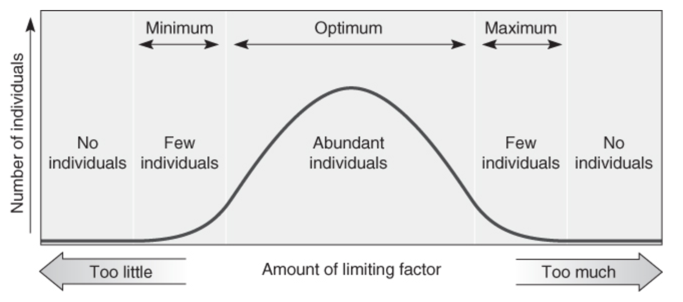
The range of tolerance
The limiting factor for a species in an ecosystem is any environmental resource present in excess of an organism's tolerance or in insufficient quantities to meet the organism's basic needs.

An organism's size, age, state of health, or genetic code can influence its tolerance range. For example, very old or young roadrunners (Geococcyx californianus) in the desert may be less able to tolerate extremely hot temperatures than mid‐aged individuals. But there is also a limit where it is too hot for any roadrunner.

Individuals within a population of a given species respond to certain factors of their environment and seemingly ignore others. Many characteristics of a habitat are variable from time to time or at different locations within the habitat. Temperature, quantity of light, moisture, soil conditions, and wind speed often vary in a forest habitat. When specific environmental factors vary continuously over a distance, a gradient exists. Light intensities can range from absolute darkness to extreme brightness. A shady spot may be a few degrees cooler than a position in direct sunlight only a few meters away. Even at a micro level, each organism has optimal conditions to thrive. Climate change and other environmental factors will affect populations based on their tolerance. For example, as a result of heat stress and climate change, New England's sugar maples (Acer saccharum) produce less sugar, which means that twice as many gallons of sap needed in the 1970s are now required to make a gallon of maple syrup (Brown, 2015).

In this exercise, using the scientific method, you will produce an appropriate experimental design to determine if a selected organism prefers certain abiotic conditions. You will then design the experiment using the equipment and materials available, carefully collect data, and analyze the data to determine which environmental variables are significant to the organism and how they are influenced by key abiotic gradients. Finally, you will create a figure that depicts a simple range of tolerance for your species and abiotic factor. The abiotic factors to choose from will be light, pH, temperature, and moisture.

Materials
Your specific experimental design will determine the materials you need to use. These should be kept track of for your lab report. Here are some examples of things available to you. There are also many things we have or can order than are not on the list so don’t feel constrained by the list when you are discussing materials required.

- Trays for containing pillbugs
- 20 pillbugs per group
- Ice/water
- Cardboard
- Paper towels
- Heat lamps (no light)
- Extra trays
- Thermometers
- pH paper/probe
- Masking tape
- Lamps
- Different wattages/colors of light bulbs
- Acidic and basic chemical solutions (vinegar, baking soda)

CONSTRUCTING A HYPOTHESIS
Develop a reasonable hypothesis predicting how your organisms are affected by your assigned variable. Conduct background research to support your reasoning for your prediction.
Example, using sharks and their range of tolerance for salinity:
“Because great white sharks are most commonly found in the open ocean which has a salinity of 35 ppt (Schlessenpoofer, 2015), the range of tolerance for salinity will show optimal survival at 35 ppt.”

2. DESIGNING AN EXPERIMENT
- Design an experiment to test the hypothesis.
  - Remember, you are also trying to construct a simplified range of tolerance based on your collected data. In your experiment, you want to choose a range based on three “zones” for your assigned variable to capture an effect (e.g., too warm, optimal, and too cold a temperature).
  - In designing your experiment, you need to be aware of other potential variables that can complicate your experiment. These variables are called confounding variables, which are variables you did not account for that can affect the outcome of your experiment. For example, if you are measuring the effects of light, excess heat from the lamp may be the variable that affects your organisms rather than the light itself, thereby undermining your results.
  - You must “control” confounding variables by eliminating all potential confounding variables. Do this by setting up a control, which consists of an identical apparatus in which you replicate everything in the treatment apparatus except the variable you are manipulating. If constructed properly, the only difference between the experiment and the control is the treatment/variable (e.g., temperature or light).
  - Remember that your experiment needs to work with the available equipment within a 1‐hour period.
  - Bring your written experimental design to the lab instructor. After it is approved, you will be provided with organisms to begin your experiment.
- Take a photograph or prepare a sketch of your apparatus and include in your lab report.

3. COLLECTING DATA
- Assemble and adjust your treatment apparatus so that you establish the specific gradients (e.g., the three zones) assigned to you. Be sure there also is a control. Then place your organisms in the control apparatus and the treatment apparatus. (i.e., in the control tray and the treatment tray).
- In the control and treatment, count and record the number of organisms every 2 minutes for a total of 10 minutes and record these data into your table. Be sure to keep notes (e.g., observations, problems) throughout the experiment to include in your lab report.
- As directed by your instructor, with new organisms, repeat the experiment (trial) two more times for a total of three trials.

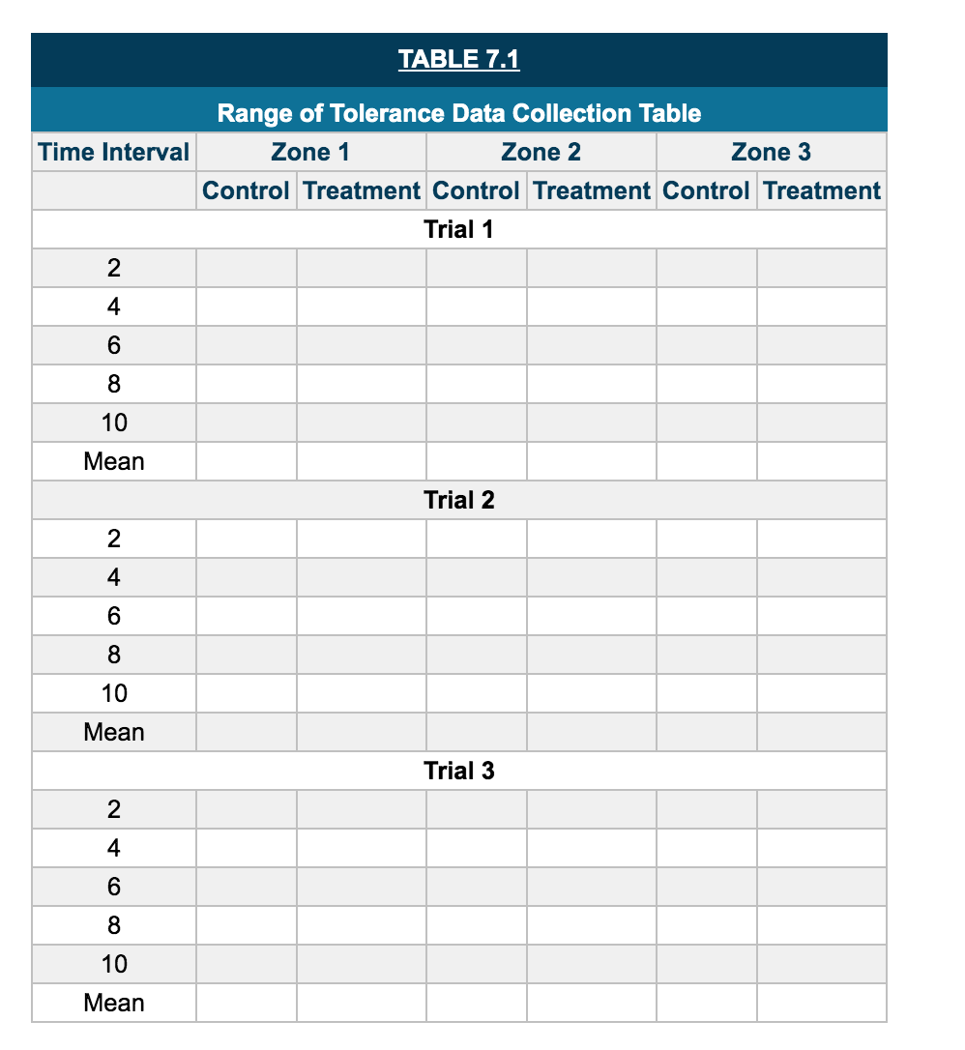

4. CONSTRUCTING A RANGE OF TOLERANCE
- Calculate the mean number of organisms for each zone and each trial.
- Create a column graph. There should be three columns (Trial 1, Trial 2, and Trial 3) for each of the three zones on the x axis. The y axis should be the mean number of organisms per trial per zone. This graph will depict a simplified range of tolerance for your organism and your abiotic variable.
- Interpret your results. Do you reject or accept your hypothesis? What were the potential confounding variables? If you were to conduct this experiment again, what would you do to improve it?

WRITEUP
A formal experiment laboratory writeup is required for this lab using the headings below.
Title (a good title!)
- Introduction--What was your organism? What background information/sources did you find to help support your hypothesis? What is the control group, IV, and DV? Be sure to end this section with your hypothesis. ½-1 page
- Materials and Methods: Materials should be listed in bulletpoint format, including amounts and sizes. Methods should be presented in recipe format (numbered list) and provide the instructions for setup and conduction of your experiment. Include either a drawn figure or photograph showing your apparatus.
- Results: Include your raw data table and your graphical representation of the range of tolerance.
- Discussion (1-2 pages)
- Restate the problem question which explains the reason for doing the lab. (“The purpose of this experiment was to determine...”)
- Was hypothesis supported, rejected or does the data leave it inconclusive? Why?
- What did the data say? Describe the graph and any trends that are visible.
- Possible causes of error (there is no experiment that will ever have none of these).
- What are some “real world” applications of this experiment? How is research into ranges of tolerance relevant to environmental problems today?
- What are new questions that have come up as a result of this experiment? What are suggestions
for further research?
- Final summary statement: Answer the original question. (“In conclusion, ...”)

AVOID USING “I, we, us, me, my, our” etc. –any pronouns—anywhere in a lab report. Example: “We knocked over and broke a beaker.” Should be: “A beaker was knocked over and broken.” (“Mistakes were made!” –Nixon)
- References Cited

Pill Bug Lab Report  Grade Rubric | Points Possible | Points Earned
Effective/Formatted Title | 1
Introduction | 5
Materials and Methods | 1
Table and Graph | 6
Discussion | 7
Works cited | 2
No pronouns | 1
Typed, printed, has name/period/date on it, on time, grammar/spelling/ formatting | 2
Total Number of Possible Points | 25

