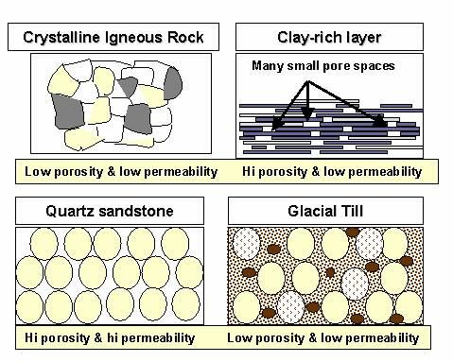
Porosity & Permeability
Name: __________________________________

Background: The porosity of a rock or rock material tells you how much of its volume is open space. The permeability of a rock is its ability to transmit water or other liquids. Both porosity and permeability are important in relation to ground water.

Materials:

- Humus, sand, or clay (grab one sample at a time)
- Beaker (100 ml)
- Graduated cylinder (for water)
- Dissecting needle
- 1 funnel
- Stopwatch
- Three coffee filters (cut to fit in funnel as instructed)
- Paper towels

Procedure:
- Measuring Pore Space in Humus, Sand and Clay
- Put 50 ml of your sample material in a 150-200 ml beaker.
- Fill a graduated cylinder with 100 ml of water.
- Slowly pour the water into the material, swirling the material if necessary, to allow water to soak all the way in to the point of saturation. This is the point at which the water and material will be seen starting to rise above the 50 ml mark on the beaker. To get to this point, you will need to use your dissecting needle to poke and move the material and allow water to fully soak throughout the sample.
- Note how much water remains in the graduated cylinder. This gets recorded under “remaining water”.
- Subtract the remaining water level from the original volume of water (100 ml) in the graduated cylinder. Record this value in the table under “Pore Space.”
- Divide Pore Space by Total volume (50 ml) to compute the percentage of pore space in your sample.
- Dispose of wet material as directed and clean up. Never pour dirt or rocks into the sink.
- Dry your beaker.
- Repeat steps 2 – 11 for the other sample materials and record your results.

Material | Total Volume (mL) | Original volume of water (mL) | Remaining water (mL) | Pore Space (mL) | % Pore Space  (porosity)
Humus | 50 | 100
Sand | 50 | 100
Clay | 50 | 100

- Measuring Permeability of Humus, Sand, and Clay
- Fold a circular filter paper in half and then in half again (it should be a cone shape).
- Open the folded filter paper it into a cone and insert it into a small funnel.
- Fill the cone (only the filter paper) with dry humus to about half of an inch from its top.
- Hold the funnel above the small beaker. Make sure the stem of the funnel is just over the small beaker.
- Using the stopwatch, time how many second it takes to fill the beaker to 10 mL with water by pouring the water through the humus. Make sure the water doesn’t pour over the sides of the funnel. Record the time (in seconds) in the data table below.
- Repeat the procedure with sand and clay.

Material | Number of Seconds | Comparative Permeability (high/medium/low)
Humus
Sand
Clay

Questions
- Compare the porosity and permeability of your samples.

Remember the definition of primary productivity: The rate of conversion of atmospheric carbon dioxide and water to organic sugars (in other words, the rate of photosynthesis or chemosynthesis.)
- What does the porosity have to do with primary productivity? Draw conclusions about the three soils.

- How does permeability affect primary productivity? Draw conclusions about the three soils.

