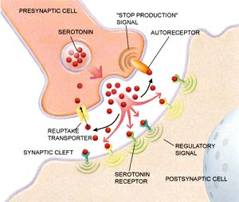
Name __________________________________________________
Review of Drug Analysis and Handwriting Analysis

True or False (if false, explain why in the space provided):
1. There are 10 major categories of handwriting analysis.
False
2. In handwriting analysis, a person’s handwriting is compared to exemplars.
True
3. A person’s handwriting is so consistent that nothing alters it.
False
4. Some forgers now use chemicals to “age” paper.
True
5. The FBI and secret service both use handwriting analysis.
True
6. The U.S. currency has orange and green threads embedded into it as a guard against counterfeiting.
False
7. Toxins are poisons only manufactured in laboratories.
False- Toxins can be natural
8. The major ways in which people are exposed to toxins are:
- ingestion
- inhalation
- injection
- and/or absorption through the skin

9. There are 6 general categories of controlled substances.
False, we learned more. Narcotics, Opioids, Stimulants, Depressants, Hallucinogens, Inhalants, etc.
10. Drugs work through different pathways in the brain.
True
11. Serotonin and Tryptophan is the molecule that is responsible for increasing alertness and energy. False

12. Dopamine is a molecule in the brain that causes one to become sad.
False

Short Answer:
13. Based on your viewing of current events and our discussions in class, tell me what you think about this statement. Accidental deaths from drug overdoses are more common than deaths from poisoning.
Heroin is one of the leading causes of death today.

14. Explain how a drug that produces a euphoria works in the brain. What molecule is likely involved? What receptors are involved?
Dopamine neurotransmitter. The drug acts as a neurotransmitter and more rapidly and efficiently binds to the receptors in the brain.

15. Name 3 ways someone might test a person for the usage of drugs.
Urine, Blood, Hair, Swab

16. Summarize the Drug Analysis lab. What happened? Who was guilty? Could we prove that they were guilty? What was the substance found in the victim?
Drugs were in solution. It was class evidence because we did not test their system for the drugs.

17. What are some “gateway” drugs. Why are they gateway drugs, and who might be using them?
Marijuana, Inhalants

18. Why is heroin use on the rise?
Cheap, Accessible
19. What are the twelve different characteristics that one might use in handwriting analysis?
Look at your notes.
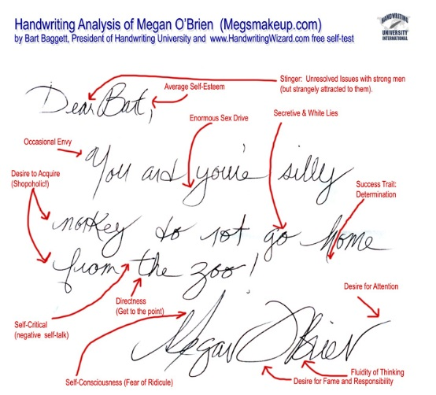
20. Define an exemplar:
Writing sample from suspect that is compared to notes at crime scene.

21. What are the three basic steps in handwriting analysis?
Find the note in question
Find an exemplar from the suspect
Compare
22. What are some methods for catching counterfeit money?
Iodine testing, tearing the bill, looking for differences in the security features.

23. From the video in class about the counterfeit millionaire, how did he get real money by using his counterfeit money?
Getting change for his counterfeit money after making small purchases.

24. Distinguish between forgery and fraudulence.
Copying/ Copying for material gains.

25. What is the difference between check forgery and literary forgery?
Checks vs. Notes being forged
26. List 3 features on a dollar bill that are used to help distinguish genuine money from counterfeit money.
Lines and boarders, Threads, Minute Writing, Raised images, etc.

27. What is the problem with printing money by using an ink jet printer?
It is “splotchy”

28. You may actually have to think for this question. We now have handwriting databases of letters and handwriting samples. How can they be analyzed using mathematical methods?
Quantitative analysis: finding percentages, counting characteristics, Measuring spacing

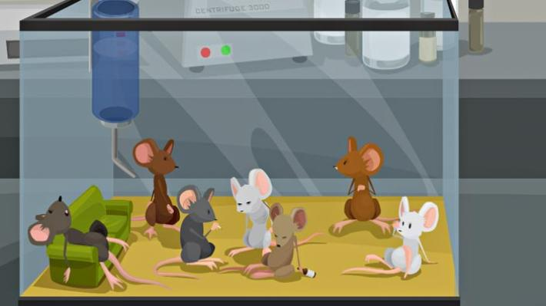
29. List one stimulant.
Cocaine
30. List one depressant.
Alcohol
31. List one hallucinogen.
LSD
32. List a narcotic.
Heroine
33. What happened in the Lindbergh case study that we viewed in class? How was handwriting analysis involved?
Ransom note and signature on bill.

34. Why should we also examine the victim’s handwriting in a case?
To see that it wasn’t written by them (example: fake note written, when it was really a suicide).

35. How can mood affect a writing sample? Give examples.
Messy, sloppy, slanted, neat, depending on mood.

