- Accident Reconstruction
- _________ Marks
- When someone breaks suddenly and locks the wheels
  - - _________________________________________________________________
  - - Calculation of velocity can be made from skid marks

- _________ Marks
  - - Produced when ____________________________________________________________________________________________________________________________________
  - - Tires and road surface melt from extreme temperatures.
  - - Audible squeal and often smoke occurs.

- _______ Scrubs
  - - Produced by Damage or overloaded tire or tires during or immediately after impact.
  - - __________________________________________________________________
  - - May have striations that look like stripes
  - - Determine an area of impact

- Dental Impressions
- Bite marks left behind at times.

- This is _______________________________ due to:

Structure of Teeth

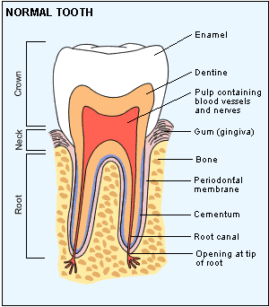

- The Development of Teeth

- - _________ primary baby teeth follows predictable pattern beginning in the first 7-12 months.
- - Primary teeth are replaced by _______ permanent adult teeth.
- - Wisdom teeth are the last to develop (ages _________________)
- - The complete adult set includes 32 teeth including wisdom teeth.
- - Can help to estimate ____________.

Types of Teeth
- Incisors-

- Canines-

- Premolars-

- Molars-

- Dentition Pattern-

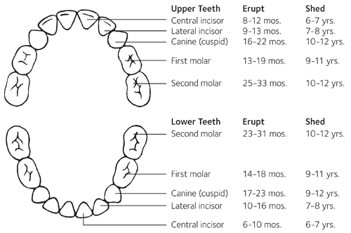

- What is the study of Teeth Called?

