CLASS TEXTBOOK ASS IGNMENT- IN PLACE OF THE UNIT 5 EXAM
Create two textbook pages for the Land and Water Use unit for the area around your home! One page will simply not be enough. Imagine these two pages are side by side in a book.
Here’s what you need to do:
- Google Earth and research the areas (approximately 5-10 mile circumference) surrounding your home. If you have another area you would like to do instead, feel free to pick another area. This might include a favorite vacation spot, a place you used to live, a place you want to visit, etc.

- Determine 3 uses for land and water in those areas. The topics covered in this unit were
- Forestry/Clearcutting
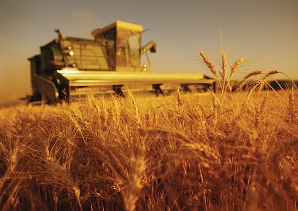
- The Green Revolution
- Agriculture, Agricultural Practices, Irrigation
- Pest Control
- Meat Production
- Overfishing
- Mining
- Urbanization and Urban Runoff
- Sustainable Agriculture and Aquaculture

- Your two textbook pages will include:
- 10 Points: A description of the area and a snapshot from Google Earth of your area. Be sure to tell me what watershed your area is included in.
- 20 Points: Identify and Explain 3 or more land and/or water uses occurring your area.
- 10 Points: Pictures that bring life to your explanations and make the textbook colorful. Make sure each image has a figurehead. Example: Figure 1 shows an image of…
- 10 Points: Identify several Pros and Several Cons to each land/water use explained.
- 10 Points: Define “Sustainability” and Describe what could be done in your area to maintain sustainability.
- 10 Points: Provide 3 statistics or graphs/charts describing what is happening in the area.
- 10 Points: Provide a current event or case study summary regarding the land/water use from your area.
- 10 Points: Cite your sources in the bottom right corner of the second page in APA citation.
- 10 Points: Make sure your work is neat and complete. It should look like two textbook pages. Grammar and Punctuation are adequate.

TURN IN VIA EMAIL BY 11:59 ON THURSDAY 3/19. My email is molly.jirasakhiran@cobbk12.org . Please reach out with any questions that you have via Remind or email.
Here are two useful links. You may use and cite them.
https://www.arcgis.com/apps/Cascade/index.html?appid=afbbb2b414ba4f76bcda33f70288390d
https://extension.uga.edu/county-offices/cobb/agriculture-and-natural-resources.html
Use may also use the PowerPoints from class on the blog, but must cite my class blog website.

