Name: ___________________________________ Per: ________
Theory of Island Biogeography
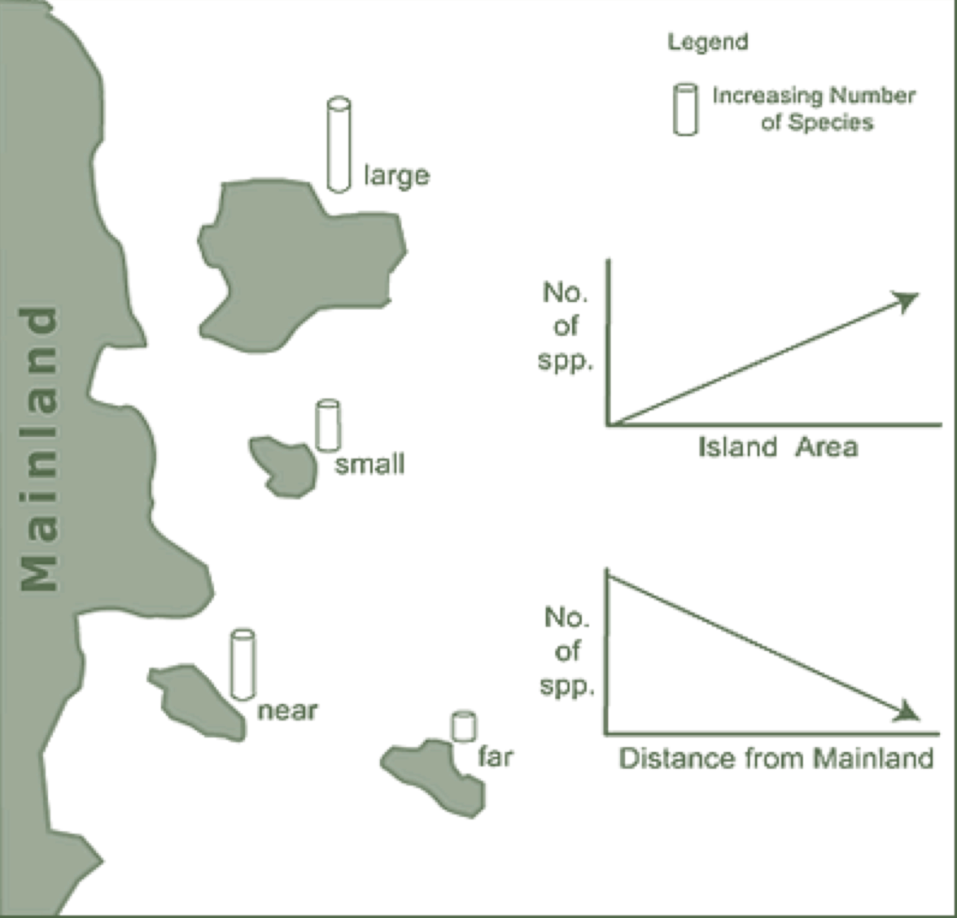

Background:
The purpose of this lab is to examine the effect that habitat fragmentation has on biodiversity. You will explore how the size of an island habitat and its distance to the main ecosystem affects its biodiversity. Specifically, you will be analyzing how likely it is for migrants from the main ecosystem to reach the various habitat islands.

Draw a mini version of your island habitat here. Label the four islands A, B, C, and D. Notice that they are far/small, far/large, near/small, and near/large.

Hypothesizing
When your species migrates from the main ecosystem out towards the four islands, which islands will receive the greatest number of immigrants and which the least? Rank the islands in order going from the one you think will receive the most immigrants to the one you think will receive the least immigrants.

Procedure
- Get the piece of butcher paper with the Main Ecosystem and the four habitat islands and then place it on the floor. Make sure it lies flat with no bumps.
- Count out 100 pinto beans into your cup. The beans will represent your migrating species.
- Hold the cup 20cm above the target dot in the center of the Main Ecosystem. Slowly let the beans fall onto the target dot. They will bounce and “migrate” all over the butcher paper. Some will make it to island habitats and live while others will not.
- Count the beans that landed in the four island habitat circles. Beans that land on the circle lines should be counted because they made it to the island’s beach. Record the data for each island in the Data Chart.
- Repeat the “migration” four more times so that you have a total of five migrations.
- Figure out the average for the five migrations for each island. Record the averages.
- Figure out the percent that each island received of the total migrants. Do this by adding up the four averages and dividing that number into each of the separate averages for each of the four islands.

Data
Year | Large close | Large far | Small close | Small far
1
2
3
4
5
Average for each island
Percentage of total migrants

Label the following graph as a class. Indicate where your four islands fell on this graph.

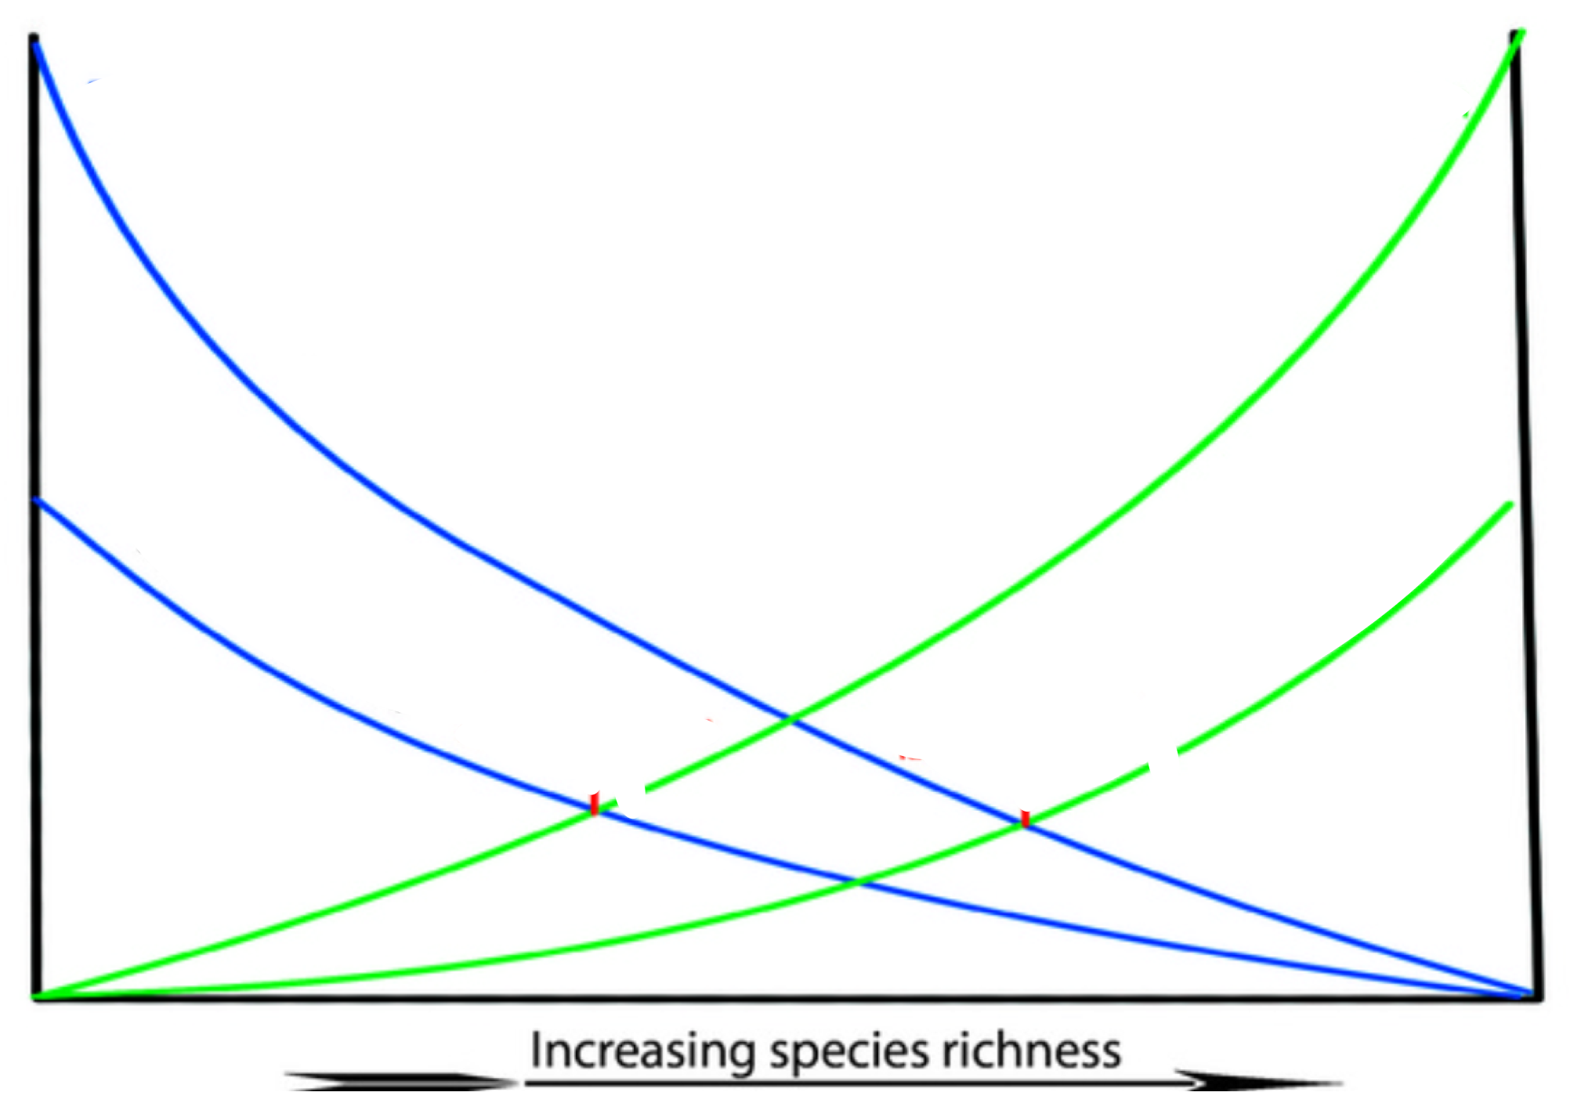

Use p. 216, 653-4 in textbook to help in answering these questions (read and discuss questions before reading)
- Was your hypothesis correct? Now that you have completed the simulation, what is your explanation for the results that you got?

- Island habitats in the ocean or a large lake are easy to visualize. What would be some examples of terrestrial “island” habitats?

- What are some of the natural barriers to species movement/migration that isolate them and create habitat islands? | - Man-made barriers?
- What are more likely to evolve on islands (after the initial colonization)—specialists or generalists? Why?

- Would invasive species be especially damaging to an island ecosystem? Why?

