Tire Treads and Impressions
- Tread pattern and measurements to ____________________________________________________________________________________________________________
- Nature of the impression to ____________________________________________________________________________________________________________

Tire tread surface is divided into ridges _________________ and grooves _________________.
The purpose of grooves is to:

Identifying a Vehicle
- Every make and model of a vehicle has its own:
- Track width=

- Wheelbase=

- Turning Diameter=

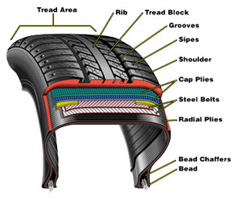

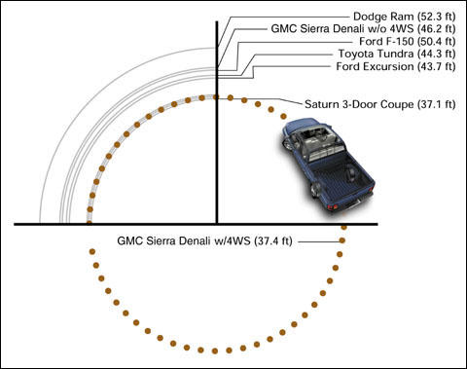
Establishing Car Movements from Tire Marks

- Vegetation disturbed as a vehicle entered or left a road

- Splash patterns created as a vehicle moved through a puddle of water or some other substance or from a wet to dry pavement.
- Substance transfer, such as oil leakage from vehicle to pavement or soil. ________________________________________________
- Tire marks on the pavement or ground.

